NATIONAL VISITOR SURVEY RESULTS

SEPTEMBER QUARTER 2023

September quarter 2023

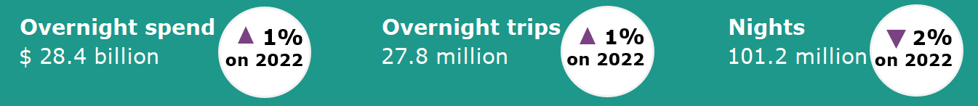

Year ending September 2023
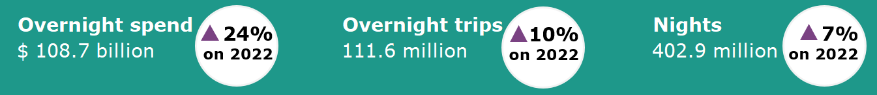

Domestic tourism growth steadies following a strong recovery
The September quarter 2023 domestic tourism results showed growth stabilising following a period of strong growth coming out of the pandemic, recording similar results to the same period last year (Figure 1) as cost-of-living pressures moderate discretionary consumption. Spend and trips increased 1% but nights fell 2%, suggesting a desire by Australians to continue travelling but take shorter trips to manage costs. Older Australians recorded strong travel results, although this was offset by softer results for younger age groups.
The year ending September 2023 results saw a strong recovery from the COVID-19 impacted year ending September 2022, with improvements in overnight spend (up 24%), trips (up 10%) and nights (up 7%). The proportion of spend in capital cities and regional areas continued to rebalance towards pre-pandemic levels.
Figure 1. Percent change for spend, overnight trips and nights compared the same period in the previous year, March quarter 2022 to September quarter 2023

Share of spend in capital cities and regions rebalancing toward pre-pandemic shares  The proportion of domestic overnight spend in capital cities and regional areas continued to rebalance towards pre-pandemic levels in the year ending September 2023.  Results for the year ending September 2023 show spend in capital cities accounted for 47% of domestic overnight spend. This is closing in on pre-pandemic levels (year ending September 2019) where capital cities accounted for 49% of domestic overnight spend. This had dropped to only 34% in 2021 as COVID-19 lockdowns across the country hit capital cities harder.  Overall, in the year ending September 2023, domestic overnight spend in capital cities was $50.6 billion, up:  - 42% or $15.0 billion on a COVID-19 impacted 2022  - 32% or $12.2 billion on 2019 | In the September quarter 2023 domestic overnight spend in capital cities was up:  - 8% or $941 million on a COVID-19 impacted 2022  - 30% or $3.0 billion on the same quarter in 2019  Figure 2: Proportion of domestic overnight spend, capital cities compared to regional areas, year ending September 2019-2023
Strength in travel by older Australians  There were large differences observed between the results for younger and older travellers (Figure 3). These differences are likely driven by cost-of-living pressures impacting age groups in different ways.  Figure 3: Percentage change in trips and spend by age group, September quarter 2023 compared to September quarter 2022  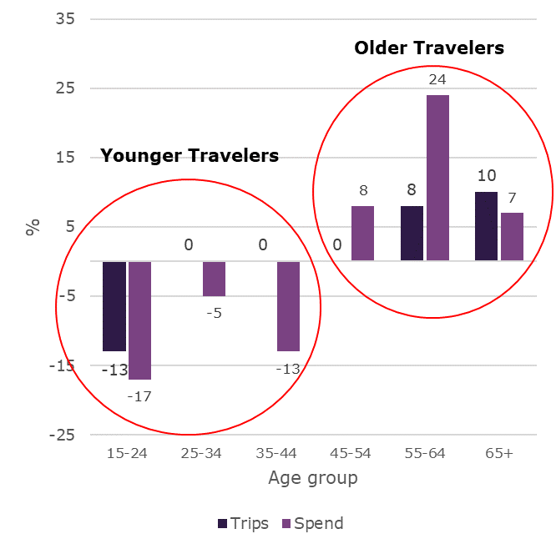 | The November CommBankiQ Cost of Living Insights report found that on average, age groups of 18-39 cut back on spending in the September quarter 2023 whereas those aged 40+ increased their spending.  Trips declined for the youngest group of travellers (15-24 years) in the September quarter 2023, down 13% on the September quarter 2022. Comparatively, older travellers aged 55-64 years and 65+ years saw increases in trips of 8% and 10% respectively.  In the September quarter 2023, larger differences were observed for spend between the age groups compared to September quarter 2022. Younger age groups saw declines in spend, which was down:  - 17% for those aged 15-24 years  - 5% for those aged 25-34 years  - 13% for those aged 35-44 years  In comparison, older age groups spent more in the September quarter 2023. Spend was up:  - 8% for those aged 45-54 years  - 24% for those aged 55-64 years  - 7% for those aged 65+ years

States and territories
Results for overnight trips and spend in the September quarter were mixed when compared to the September quarter 2022 (Figure 4).
Victoria, South Australia, Tasmania and the Australian Capital Territory recorded increases in both overnight trips and spend, while the Northern Territory saw decreases. Results for New South Wales, Queensland and Western Australia were mixed. Spend was up while the number of trips fell in Queensland and Western Australia but spend was down and trips on par in New South Wales when compared to the September quarter 2022.
Victoria saw the largest increase in trips (up 149,000 or 2%) followed by Tasmania (up 142,000 or 28%). The largest decrease was in the Northern Territory (down 106,000 or 18%)
Queensland saw the largest increase in spend (up $238 million or 3%) followed by Western Australia (up $182 million or 6%). The largest decreases were in New South Wales (down $301 million or 4%) and the Northern Territory (down $115 million or 10%).
Figure 4. Overnight trips and spend by state and territory, September quarter 2023 compared to September quarter 2022
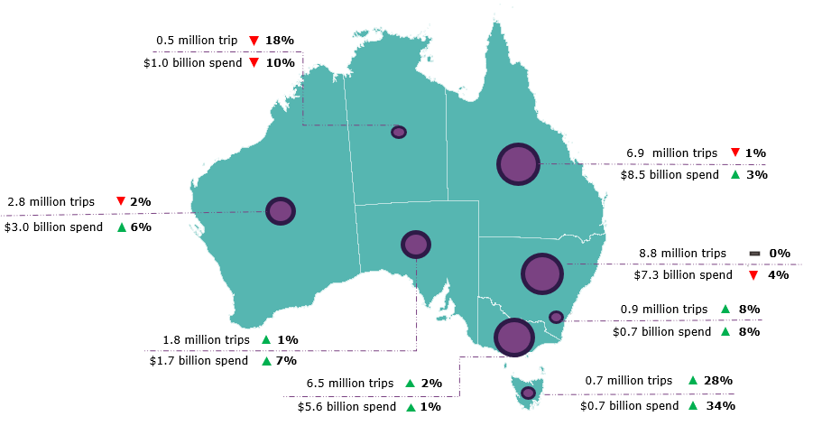
Year ending September 2023
In the year ending September 2023, Australians took 111.6 million trips for 402.9 million nights away and spent $108.7 billion. Compared to the year ending September 2022 (COVID-19 impacted), this was:
- up 10.0 million or 10% for overnight trips
- up 26.3 million or 7% for nights away
- up $20.9 billion or 24% for spend.

Compared to the year ending September 2019, this was:
- down 4.1 million or 4% for overnight trips
- down 7.2 million or 2% for nights away
- up $29.6 billion or 37% for spend.

This report has been prepared by the Commonwealth of Australia represented by the Australian Trade and Investment Commission (Austrade). The report is a general overview and is not intended to provide exhaustive coverage of the topic. The information is made available on the understanding that the Commonwealth of Australia is not providing professional advice. While care has been taken to ensure the information in this report is accurate, the Commonwealth does not accept any liability for any loss arising from reliance on the information, or from any error or omission, in the report.

