Tourism Businesses in Australia, June 2017 to June 2022

Tourism Research Australia
Australian Trade and Investment Commission (Austrade)
Email: tourism.research@tra.gov.au
Web: www.tra.gov.au
Publication date: March 2023

Acknowledgement of Country
In the spirit of reconciliation, we acknowledge the Traditional Custodians of country throughout Australia and their connections to land, sea, and community. We pay our respect to their elders past and present and extend that respect to all Aboriginal and Torres Strait Islander peoples today.

Publication acknowledgements
This work should be attributed as Tourism Businesses in Australia, June 2017 to June 2022, Tourism Research Australia, Austrade, Canberra. It draws on tourism business counts supplied to Tourism Research Australia by the Australian Bureau of Statistics.
This report is available at www.tra.gov.au
Further enquiries are welcome at tourism.research@tra.gov.au

The term ‘tourism’ in the international standards is not restricted to leisure activity. It includes travel for business or other reasons, such as education, provided the destination is outside the person’s usual environment. Therefore, tourism is a demand-side phenomenon and is defined, first, by an individual’s movement out of their usual environment, and, second, by the type of goods and or services consumed by the individual. Visitor demand for transport, travel experiences and accommodation needs to be complemented by supply-side capacity. This report provides a record of key characteristics of the businesses that together comprise the supply side of Australia’s visitor economy.

Disclaimer
This report has been prepared by the Commonwealth of Australia represented by the Australian Trade and Investment Commission (Austrade). The report is a general overview and is not intended to provide exhaustive coverage of the topic. The information is made available on the understanding that the Commonwealth of Australia is not providing professional advice.
While care has been taken to ensure the information in this report is accurate, the Commonwealth does not accept any liability for any loss arising from reliance on the information, or from any error or omission, in the report.
Any person relying on this information does so at their own risk. The Commonwealth recommends the person exercise their own skill and care, including obtaining professional advice, in relation to their use of the information for their purposes. The Commonwealth does not endorse any company or activity referred to in the report, and does not accept responsibility for any losses suffered in connection with any company or its activities.

Copyright
Copyright © Commonwealth of Australia 2023
The material in this document is licensed under a Creative Commons Attribution – 4.0 International licence, with the exception of:
- the Commonwealth Coat of Arms
- the Australian Trade and Investment Commission’s logo
- any third party material
- any material protected by a trade mark
- any images and photographs.
More information on this CC BY licence is set out at the creative commons website: https://creativecommons.org/licenses/by/4.0/legalcode.
Attribution
Before reusing any part of this document, including reproduction, public display, public performance, distribution, dissemination, communication, or importation, you must comply with the Attribution requirements under the CC BY licence. Enquiries about this licence and any use of this document can be sent to: advisory@austrade.gov.au.

Use of the Coat of Arms
The terms of use for the Coat of Arms are available from the It’s an Honour website (www.itsanhonour.gov.au).

Publication date: March 2023

Contents

Executive summary 4
About this report 4
Businesses by industry 5
Businesses by size 6
Businesses by turnover 7
Businesses by location 8

Methodology
The data used to produce these counts are extracted from the Australian Bureau of Statistics Business Register (ABSBR). The ABSBR is populated using administrative data from Australian Business Number (ABN) registrations recorded in the Australian Business Register (ABR), and business data from the Australian Taxation Office (ATO).
For the purposes of this Tourism Businesses in Australia report, a business is defined as a legal entity engaging in productive activity and/or other forms of economic activity in the market sector. Businesses are defined as engaging in productive activity where they have a Goods and Services Tax (GST) role and are actively remitting GST through Business Activity Statements (BAS).
Counts of businesses in this release include only actively trading businesses in the Australian market sector through to end-June 2022. Actively trading businesses are:
- ABNs from the non-profiled population that are actively remitting Goods and Services Tax (GST) – most of the businesses in the ABSBR are in this group and most have simple structures that are suitable for ABS statistical purposes at the ABN level. One ABN equates to one business
- Types of Activity Unit (TAUs) from the profiled population – the small number of businesses/groups of businesses that are large, complex and diverse and for which the ABS maintains its own economic unit structure.

Executive summary

Between June 2017 and June 2022, the number of tourism businesses in Australia increased 21% from 296,910 to 358,277. There were 3 distinct phases during this period:
- Phase 1 – pre-pandemic, tourism business numbers increased by 5.9% in 2018 and 3.1% in 2019
- Phase 2 – through the peak of the pandemic, growth in tourism business numbers was slower at 1.6% in 2020 and 3.0% in 2021
- Phase 3 – with the improved trading environment, the number of tourism businesses grew by 5.7% or 19,233 in the year to June 2022.
During the Phase 2 pandemic period, there was also a shift in the size profile of tourism businesses. For example, the number of businesses with fewer than 20 employees increased by 5.1% while the number of larger tourism businesses declined by 5.5% in the 2 years to June 2021.
In the Phase 3 period (2021-22), tourism demand rebounded strongly led by a
year-on-year increase of 17% in visitor spend, mostly driven by the domestic travel market. The addition of 19,233 tourism businesses in that year was the largest volume increase for tourism businesses over the reporting period. However, most of the growth (85% or 16,416) was concentrated in non-employing tourism businesses.

Figure 1. Tourism businesses, June 2017 to June 2022
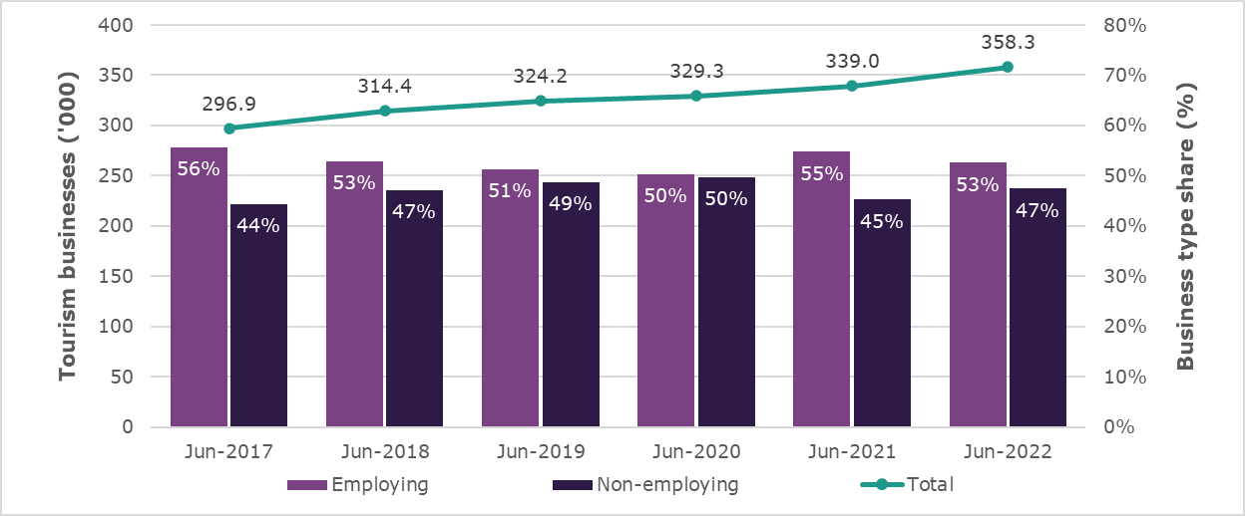

About this report

Although tourism was hit particularly hard by COVID-19, the number of businesses continued to grow during the pandemic. This can be attributed to:
- an increase in the number of micro and small businesses, most often in the retail and cafe, restaurant and take-away sector, where online and home delivery services expanded
- the delivery of various support programs by governments which allowed many businesses to keep operating on reduced turnovers.
In 2022, as Australia emerged from the pandemic and tourism started its long road to recovery, there was a stronger increase in tourism businesses than at any time since 2018. There were 358,277 tourism businesses in Australia as at June 2022, up 5.7% or 19,233 on the previous year.
While the increase in the number of tourism businesses is significant, the growth recorded was slightly lower than the average across all Australian businesses (7.0%) in 2022. Nonetheless, 1 in 7 Australian businesses (14%) was directly connected to tourism at 30 June 2022.
This report provides statistics on movement in the number of Australia’s tourism businesses over the June 2017 to June 2022 period. It also examines the profile of these businesses, including their:
- industry coverage
- size
- turnover
- geographic spread.
By presenting information over this timeframe, the report reveals:
- strong growth in tourism businesses prior to the pandemic (Phase 1)
- severe disruption to Australia’s visitor economy in 2020 and 2021 (Phase 2)
- a resurgence in tourism business numbers in 2022 as tourism demand progressively increased (Phase 3).

Businesses by industry

Tourism businesses operate across a range of Australian industry sectors. As at June 2022, the industry segments accounting for most tourism businesses were:
- Retail trade (44% or 156,760 businesses)
- Cafes, restaurants, and take-aways, including pubs, clubs, taverns, and bars
(27% or 96,549 businesses)
- Taxi transport (10% or 36,361 businesses)
- Cultural, sports, and recreation (10% or 35,778 businesses).
The industry profile of tourism businesses has changed considerably since 2017
(Table 1). For example, in June 2022, there were:
- 46% or 861 more motor vehicle hiring businesses than in 2017, including
363 businesses added in 2022 as people enjoyed increased mobility following the lifting of travel restrictions
- 39% more taxi transport businesses than in 2017 despite their number having fallen by over 6,000 from a peak of 42,495 in 2020 when driven by growth in ride share services
- 34% or 9,076 more arts, sports, and recreation services-related businesses than in 2017, with the largest year-on-year growth in 2022 after social distancing restrictions were lifted
- 21% or 1,502 more travel agency and tour operator services businesses than in 2017, although the number remains down 356 on the 9,003 businesses in 2020, and noting an increase in those operating as mobile and very small travel agents
- 18% or 23,605 more retail trade services businesses than in 2017, including strong growth in 2022 led by online businesses
- 18% or 14,380 more cafes, restaurants, and take-away businesses than in 2017, with the strongest growth occurring over the past 2 years partly due to an increase in online food delivery businesses
- 8% or 1,029 more accommodation businesses than in 2017, of which 411 were added in the year to June 2022, a period where recovery in domestic overnight travel gained momentum.
Table 1. Tourism businesses by industry, June 2017 to June 2022
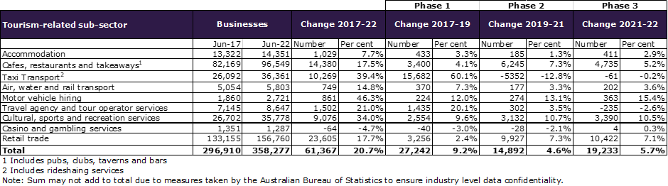
Overall, the number of tourism businesses increased by 19,233 between June 2021 and June 2022. This growth was largely concentrated in 3 industry sectors:
- Retail trade services – 10,422 more businesses, of which 39% were non-store retailing and/or retail commission based (online business) entries
- Cafes, restaurants, and take-away services – 4,735 more businesses including 61% that were non-employing businesses (mainly take-away businesses)
- Cultural, sports and recreation services – 3,390 more businesses of which
three-quarters were added to the creative arts sector where non-employing artists, musicians and performers are prominent.

Businesses by size

Tourism businesses are classified as non-employing, micro (1-4 employees), small
(5-19 employees), medium-sized (20-199 employees) or large (200 or more employees). Most (around 95%) are small operations with fewer than 20 employees. In June 2022:
- 48% or 172,263 were micro or small enterprises
- 47% or 169,897 had no employees other than the owner.
Despite the prominence of small businesses within the tourism sector, trading conditions contributed to notable shifts in the size of business operations within the June 2017 to June 2022 reporting period:
- Led by rapid growth in ride sharing transport services, non-employing tourism businesses (up 20% or 26,110) dominated growth in the 2 years to 2019
- With direct tourism GDP and employment growing 11.9% and 7.9% respectively, medium-sized to large businesses (5.4% or 830) also had much stronger growth than micro to small businesses (0.2% or 300) over the same period
- The pandemic period from 2019 to 2021 brought a recalibration. The number of micro to small businesses grew (up 13% or 20,164), while the number of non-employing businesses (down 3% or 4,375) and medium-sized to large businesses (down 6% or 897) both contracted
- The past year to June 2022 has seen a resurgence in the number of
non-employing tourism businesses (up 11% or 16,416). The Australian Bureau of Statistics (ABS Cat. No 8165.0) reported an around 10% movement in total businesses from the employing to non-employing category during 2021-22
- Growth for employing tourism businesses was modest in comparison (1.5% or 2,817) and this varied:
  - Medium-sized increased by 5.8% (or 830 businesses)
  - Small increased by 2.1% (or 1,220 businesses)
  - Micro increased by 0.7% (or 762 businesses)
  - Large increased by 0.6% (or 5 businesses).
Over the full reporting period from June 2017 to June 2022, non-employing operators accounted for 62% of the growth in tourism businesses. The number of micro to small businesses grew at 3 times the rate of medium-sized to large businesses (15% compared with 5%) over the same period due largely to increases recorded in the 2019 to 2021 period (Table 2).
Table 2. Tourism businesses by size, June 2017 to June 2022
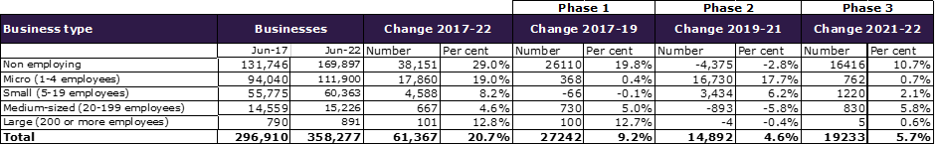

The June 2022 tourism business counts also highlight that:
- Nearly all taxi transport (96%) and a large portion of cultural services (79%) and motor vehicle hiring (73%) businesses were non-employing
- More than two-thirds (70%) of all cafes, restaurants and take-aways were micro or small businesses with 1 to 19 employees
- The share of businesses that were medium-sized to large was largest for the pubs, clubs, taverns, and bars sector (21%).

Businesses by turnover

Turnover is an indicator of the demand for, and value and quantity of, goods and services offered by businesses. As at 30 June 2022:
- 29% or 103,039 tourism businesses had turnover of less than $50,000
- 24% or 84,263 tourism businesses had turnover between $50,000 and $200,000
- 37% or 133,499 tourism businesses had turnover between $200,000 and
$2 million
- 10% or 37,191 tourism businesses had turnover of $2 million or more.
Over the June 2017 to June 2022 reporting period, the number of tourism businesses with turnover under $50,000 grew by 49% or 34,035. With the pandemic impacting business turnover and strong growth in non-employing businesses, the proportion of all tourism businesses with a turnover under $50,000 increased from 23% in June 2017 to a high of 30% by June 2021 before inching back to 29% in June 2022.
However, highlighting the recovery underway within the tourism sector, the strongest growth in businesses in the year to June 2022 was concentrated among those reporting higher turnover.
- Businesses with turnover up to $200,000 increased by 4.2% or 7,627
- Businesses with turnover of $200,000 to $2 million increased by 6.3% or 7,891
- Businesses with turnover of $2 million or more increased by 11% or 3,621
(Figure 2).

Figure 2. Tourism businesses by turnover range, June 2017 to June 2022
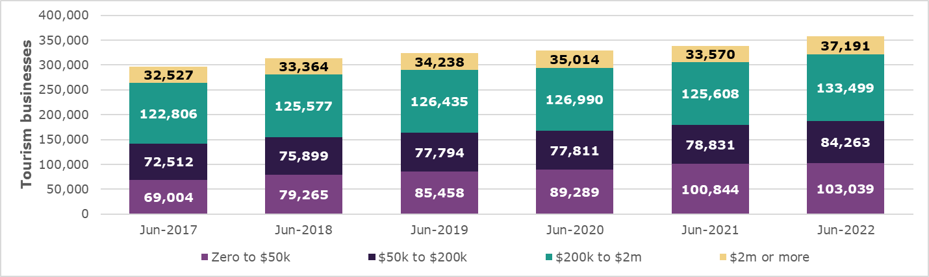

Businesses by location

In June 2022, most tourism businesses (82%) were in:
- New South Wales (NSW) – 117,781
- Victoria (VIC) – 111,400
- Queensland (QLD) – 64,038.
Overall, VIC had one tourism business for every 59 residents living in the state while NSW had one for every 69 residents. All other states and territories had one tourism business for 80 or more residents.
Tourism business numbers grew at different rates across the states and territories between June 2017 and June 2022:
- VIC had the strongest average annual growth rate of 6.2%, which was bumped upwards by an 11.4% or 11,436 increase in the year to June 2022
- The Northern Territory (NT) and the Australian Capital Territory (ACT) both had an average annual growth rate of 3.4%, although both experienced higher than average growth in the year to June 2022 (NT 6.7%, ACT 4.5%)
- QLD and NSW the same average annual growth rate of 3.0%: in the year to June 2022, QLD was 3.8% and NSW was 2.7%
- Tasmania (TAS) had an average annual growth rate of 2.7%, which was slightly higher than for the year to June 2022 (2.3%)
- South Australia (SA) had an average annual growth rate of 2.5%, which was nearly doubled in the year to June 2022 (4.8%)
- Western Australia (WA) had an average annual growth rate of 1.9%, which was bettered in the year to June 2022 (2.8%) (Figure 3).

Figure 3. Tourism businesses by states and territories
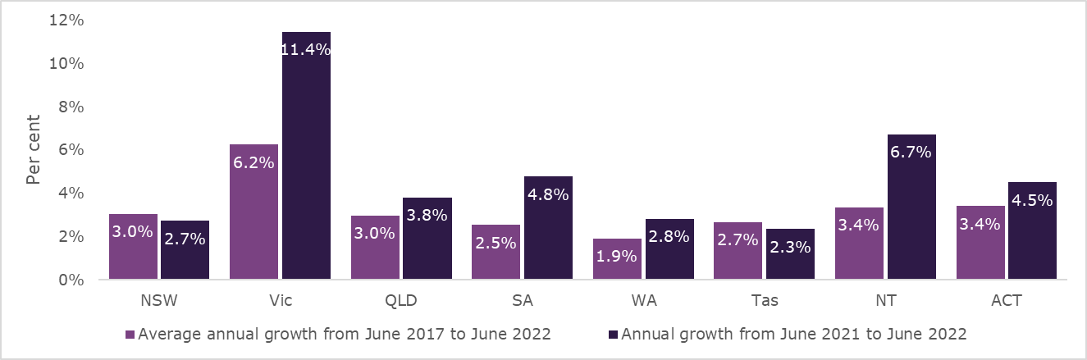

Capital city tourism regions were home to 70% or 250,710 of all tourism businesses at 30 June 2022, while 107,567 tourism businesses were spread across regional areas of Australia. The capital cities have 1 tourism business for every 66 residents which is a higher rate than the 1 in every 84 residents for regional areas. However, the share of all tourism businesses with employees is higher in regional Australia (59%) than capital cities (50%).
The number of tourism businesses in regional Australia increased at an annual average rate of 2.3% between June 2017 and June 2022, compared with 4.5% for capital cities. Although the number of businesses in regional Australia grew at more than twice the
5-year average in the year to June 2022 (4.9% or 5,037), this was still lower than the 6.0% or 14,196 increase for capital cities over this period. The softer growth rate in regional areas led to a decrease in the regional share of all tourism business from 32.3% in June 2017 to 30.0% in June 2022.
The growth in tourism businesses for regional Australia in the year to June 2022 was led by medium-sized (12.5% or 614) and non-employing (9.9% or 4,018) operators.
Non-employing businesses (11.0% or 12,398) were the main driver of growth for capital cities over the same period (Table 3). Regional areas accounted for a larger share of all medium-sized to large (37%) than micro to small (33%) or non-employing (26%) tourism businesses at 30 June 2022.

Table 3: Tourism businesses by capital city/region, June 2022
Business type | Regional Australia |  | Capital cities
 | Businesses | Change on June 2021 | Businesses | Change on June 2021
Non-employing | 44,499 | 9.9% | 125,398 | 11.0%
Micro | 34,605 | -0.8% | 77,295 | 1.4%
Small | 22,463 | 3.1% | 37,900 | 1.4%
Medium-sized | 5,526 | 12.5% | 9,700 | 2.3%
Large | 474 | -1.7 | 417 | 3.2%
Total | 107,567 | 4.9% | 250,710 | 6.0%

As Figure 4 shows each of the capital city tourism regions (except Darwin) feature among the twenty regions with the most tourism businesses at 30 June 2022. North Coast (NSW), Hunter (NSW), Sunshine Coast (QLD), South Coast (NSW) and Tropical North Queensland (QLD) are the regional areas with most tourism businesses.

Figure 4: Number of tourism businesses by region, June 2022
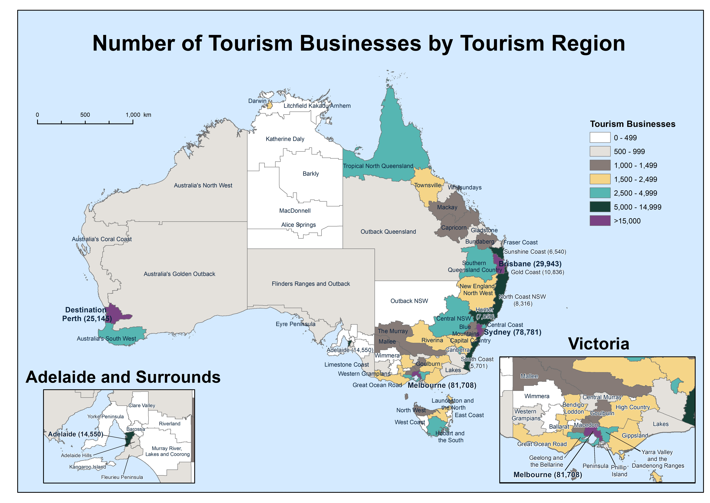

The reference to $200,000 is shorthand for any value up to but below $200,000 (e.g. $199,999).
The reference to $2 million is shorthand for any value up to but below $2 million (e.g. $1,999,999).
References to capital cities in this report include tourism regions all 8 state and territory capitals and the Gold Coast, which is combined with Brisbane.

