INTERNATIONAL VISITOR SURVEY RESULTS

December QUARTER 2024

## December quarter 2024

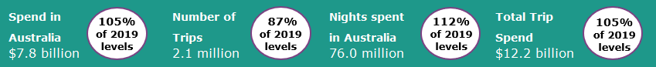

## Year ending December 2024

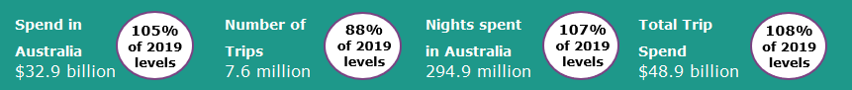

**International tourism remains steady**

The December quarter 2024 international tourism results were stable when compared with the September quarter 2024 results as a percentage of pre COVID levels. Spend in Australia and nights spent in Australia both exceeded pre COVID levels, reaching 105% (on par with September quarter 2024) and 112% (up from 102% in September quarter 2024), respectively. Trips to Australia improved, however remained below pre COVID levels at 87% of the level in the December quarter 2019 (up from 86% in September quarter 2024). The average duration of international visitor stays continued to increase, reaching 36 days, following the same trend seen in recent quarters.

The results for the whole of 2024 saw international tourism to Australia continue to approach pre-COVID levels. Spend, trips and nights away all saw improvements as a percentage of pre-COVID levels, relative to year ending September 2024 results.

**Figure 1: Percentage of spend, nights and trips in Australia compared to 2019 levels, December quarter 2023 to December quarter 2024**

## Top 5 Visitor Markets

The top 5 visitor markets in 2024 were New Zealand, China, the United States of America, the United Kingdom and India. China saw the largest improvement on a year basis, compared to 2023, with spend increasing by 38% (from $5.8 billion to $8.1 billion) and trips increasing by 63% (from 507,000 to 829,000). China was also the largest contributor to spend in Australia in 2024, making up 25% of the total, followed by the United Kingdom at 6.7% and New Zealand at 6.3%.

Australia’s top 5 international visitor markets in 2024 were (2019 comparison in brackets):

1. New Zealand with:

* 1.3 million trips (97%)
* $2.1 billion spent (127%)
* 14.8 million nights (114%)

2. China with:

* 829 thousand trips (62%)
* $8.1 billion spent (78%)
* 45.1 million nights (78%)

3. United States of America with:

* 669 thousand trips (87%)
* $2.0 billion spent (103%)

4. United Kingdom with:

* 605 thousand trips (90%)
* $2.2 billion spent (123%)
* 21.9 million nights (107%)

5. India with:

* 421 thousand trips (112%)
* $1.7 billion spent (131%)
* 28.8 million nights (133%)
* 12.1 million nights (94%)

**Figure 2. Top 5 markets by spend in Australia (percentage of 2019 levels), year ending December 2021 to year ending December 2024**

## States and Territories

In 2024, all states and territories except Queensland and South Australia saw relative improvements in trips compared with the year ending September 2024.

International visitor spending also increased in 2024 in over half of the states and territories relative to the year ending September 2024 results, as a percent of pre COVID levels. This was driven by New South Wales (106%, up from 104%), Victoria (102%, up from 100%), Western Australia (110%, up from 104%), the Australian Capital Territory (111%, up from 103%), and the Northern Territory (107%, up from 99%).

These increases were partially offset by South Australia (112%, down from 117%), Queensland (102%, down from 103%) and Tasmania (99% down from 104%).

**Figure 3. Number of trips and spend in Australia by state and territory, year ending December 2024 as a percentage of 2019 levels (year ending September 2024 comparison in brackets)**

This report has been prepared by the Commonwealth of Australia represented by the Australian Trade and Investment Commission (Austrade). The report is a general overview and is not intended to provide exhaustive coverage of the topic. The information is made available on the understanding that the Commonwealth of Australia is not providing professional advice. While care has been taken to ensure the information in this report is accurate, the Commonwealth does not accept any liability for any loss arising from reliance on the information, or from any error or omission, in the report.