INTERNATIONAL VISITOR SURVEY RESULTS

MARCH QUARTER 2024

March quarter 2024
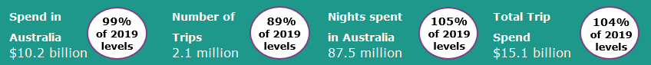

Year ending March 2024
International tourism closes in on full recovery
The March quarter 2024 international tourism results saw an uptick in trips to Australia relative to pre-pandemic. Trips reached 89% of pre-COVID levels (up from 81% in December quarter 2023) driven by an influx of travellers from China here for holiday and education purposes. Nights away exceeded pre-COVID levels at 105% (up from 101% in December quarter 2023) while spend in Australia was 99% of pre-COVID levels (up from 97% in December quarter 2023). The flatter spend recovery is likely driven by uncertain global economic conditions and heightened inflation impacting discretionary spending (Figure 1).
The year ending March 2024 results saw international tourism to Australia edge closer to 2019 levels (pre-COVID). Spend, trips and nights away all saw improvements as a percentage of pre-COVID levels, compared with last quarter’s data, with all exceeding 84% of pre-COVID levels. The average spend in Australia per trip increased by 25% when compared to pre-COVID due to travellers staying longer, with an average stay of 37 nights (up from 32 nights in 2019).
Figure 1: Percentage of spend, nights and trips in Australia compared to 2019 levels, March quarter 2023 to March quarter 2024
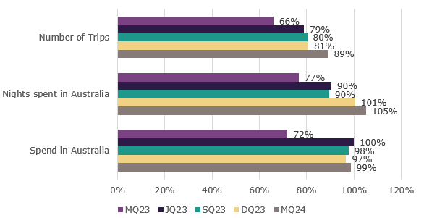

Uptick in holiday and education travel from China
The March quarter 2024 saw an influx of travellers from China for holiday and education purposes when compared with the March quarter 2023. Travel from China continues to recover following Chinese outbound travel re-opening in early 2023, later than other markets.
The China visitor market saw:
- holiday trips and spend reach 48% and 52% of pre-COVID levels, respectively (up from both being only at 3% in the March quarter 2023).
- Education trips and spend reach 66% and 71% of pre-COVID levels, respectively (up from 36% and 46%, respectively in the March quarter 2023).

While there was an uptick for holiday and education travellers from China in the March quarter 2024, the average spend per trip has moderated for the past 4 quarters when compared to pre-COVID. This is driven by an average spend per trip for travellers here for education purposes returning to pre-COVID levels. This may reflect a return to more normal spending behaviour following a period where visitors were able to draw on savings built up during COVID-19 period and the current global economic uncertainty weighing on spending decisions (Figure 2).
Figure 2: Average spend in Australia per trip (percentage of 2019 levels) of travellers from China, March quarter 2023 to March quarter 2024
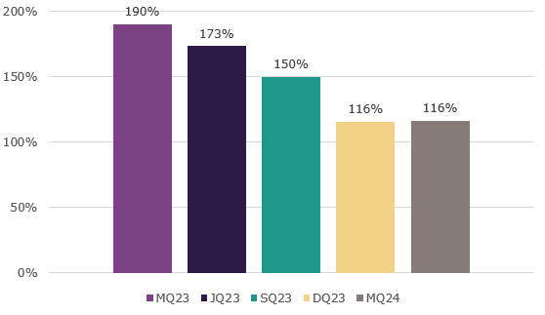

Top 5 Visitor Markets
In the year ending March 2024, 4 of the top 5 visitor markets (New Zealand, India, United Kingdom and United States of America) exceeded their 2019 spend levels. Trips to Australia continued to improve across the top 5 markets, with India exceeding 2019 levels (114%). China saw the largest improvement as a percentage of pre-COVID levels on a year-ending basis, compared with last quarter’s data, with spend and trips at 73% (up from 56%) and 51% (up from 38%) respectively. China has become the second largest international visitor market, up from being the fourth largest in the year ending December 2023.
Australia’s top 5 international visitor markets in the year ending March 2024 were (2019 comparison in brackets):

1. New Zealand with:
- 1.2 million trips (96%)
- $2.1 billion spent (128%)
- 14.4 million nights (111%)
2. China
- 681 thousand trips (51%)
- $7.2 billion spent (73%)
- 39.0 million nights (68%)
3. United States of America with:
- 663 thousand trips (88%)
- $2.1 billion spent (106%)
- 11.3 million nights (86%)
4. United Kingdom with:
- 578 thousand trips (86%)
- $2.0 billion spent (108%)
- 20.0 million nights (94%)
5. India with:
- 390 thousand trips (114%)
- $1.5 billion spent (121%)
- 23.8 million nights (114%)

Figure 3. Top 5 markets by spend in Australia (percentage of 2019 levels), year ending March 2021 to year ending March 2024
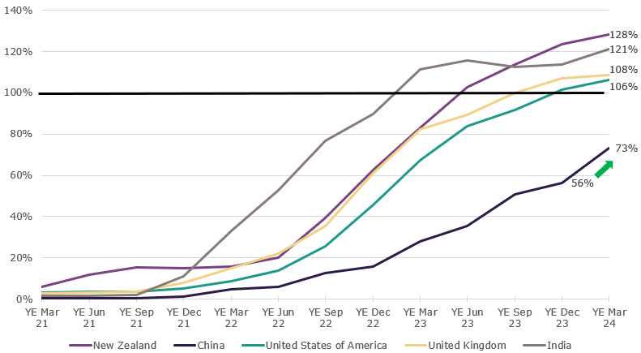

States and Territories
In the year ending March 2024, results were stronger across all states and territories for spend and trips to Australia as a percentage of pre-COVID levels, compared with last quarters data (excluding spend in the Northern Territory).
Half of the states and territories exceeded 2019 spend levels with South Australia the strongest at 120%, followed by Western Australia (111%), New South Wales (105%) and Queensland (102%).
New South Wales and Victoria drove the stronger relative spend and trip results, compared with last quarter’s data, due to an influx of travellers from China at the start of 2024, here for holiday and education purposes.
Figure 4. Number of trips and spend in Australia by state and territory, year ending March 2024 & year ending December 2023 (as percentages of 2019 levels)
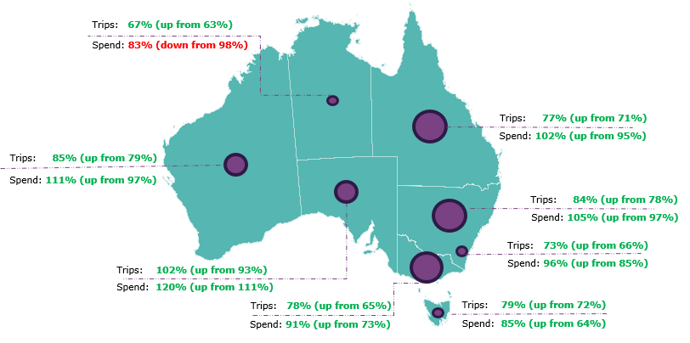
This report has been prepared by the Commonwealth of Australia represented by the Australian Trade and Investment Commission (Austrade). The report is a general overview and is not intended to provide exhaustive coverage of the topic. The information is made available on the understanding that the Commonwealth of Australia is not providing professional advice. While care has been taken to ensure the information in this report is accurate, the Commonwealth does not accept any liability for any loss arising from reliance on the information, or from any error or omission, in the report.

