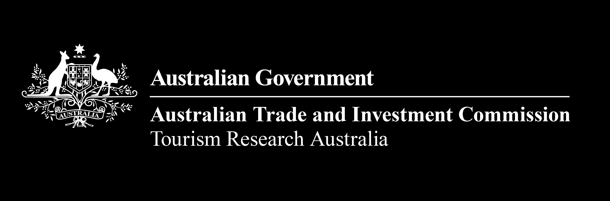

# Visitor Economy Profile 2023-24: Singapore

Singapore is Australia’s sixth largest inbound market, reaching 84% of pre-pandemic levels in FY2023-24. Total spend from Singapore visitors was $1.1 billion for FY2023–24.

## Visitor numbers

* Total visitors: 392,300
* Change vs last year: +10%
* Change vs pre-pandemic: -16%
* Rank: 6th

## Visitor group type

* Solo traveller: 50% (Total INT*: 57%)
* Adult couple: 17% (Total INT: 20%)
* Family: 22% (Total INT: 12%)
* Other: 11% (Total INT: 11%)

*Total INT = The average for total international visitors to Australia

## Visitor spend

* Average visitor spend: $3,300
* Total spend in Australia: $1.1 billion
* Change in total spend vs last year: +8%
* Change in total spend vs pre-pandemic: +3%

Singapore is forecast to return to pre-pandemic levels in in 2026. 4 in 5 Singaporean visitors come to Australia for a holiday or visiting friends and relatives (VFR).

## Forecast visitor growth

**Table 1:** **Forecast visitors to Australia from 2015 to 2029**

| **Year** | **Singapore visitors to Australia** |
| --- | --- |
| 2015 | 387,000 |
| 2016 | 430,000 |
| 2017 | 433,000 |
| 2018 | 448,000 |
| 2019 | 479,000 |
| 2020 | 58,000 |
| 2021 | 16,000 |
| 2022 | 296,000 |
| 2023 | 364,000 |
| 2024 | 425,000 |
| 2025 | 457,000 |
| 2026 | 483,000 |
| 2027 | 504,000 |
| 2028 | 519,000 |
| 2029 | 533,000 |

## Main reason for visitation

**Table 2:** **Main reason for visitation**

| **Reason** | **Number of visitors from Singapore** | **Percentage of visitors from Singapore** | **Total INT percentage of visitors\*** |
| --- | --- | --- | --- |
| Holiday | 236,100 | 60% | 43% |
| Visiting Friends or Relatives (VFR) | 87,100 | 22% | 34% |
| Business | 44,300 | 11% | 9% |
| Education | 10,600 | 3% | 6% |
| Employment | 3,900 | 1% | 4% |
| Other | 10,300 | 3% | 4% |

## Where visitors stay

**Table 3:** **Where visitors stay**

| **Location** | **Percentage of visitors from Singapore** | **Total INT percentage of visitors\*** |
| --- | --- | --- |
| Capital cities & Gold Coast | 97% | 93% |
| Rest of Australia | 24% | 29% |
| New South Wales | 29% | 50% |
| Victoria | 38% | 34% |
| Queensland | 11% | 29% |
| South Australia | 5% | 6% |
| Western Australia | 29% | 11% |
| Tasmania | 4% | 3% |
| Northern Territory | 1% | 3% |
| ACT | 1% | 2% |

Singaporean visitors spend less nights in Australia compared to the average international visitors. Key demand-driving experiences includes social and outdoor activities, local attractions and going to the market.

## Nights stayed

**Table 4:** **Nights stayed**

| **Nights** | **Number of visitors from Singapore** | **Percentage of visitors from Singapore** | **Total INT percentage of visitors\*** |
| --- | --- | --- | --- |
| 1–7 nights | 183,900 | 54% | 34% |
| 8–14 nights | 95,700 | 28% | 23% |
| 15–30 nights | 32,100 | 9% | 17% |
| 31 or more nights | 26,100 | 8% | 25% |

## Visitor experience rating and trip type

* Positive trip sentiment (7+ out of 10): 96% (Total INT: 96%)
* First trip to Australia: 19% (Total INT: 36%)
* Return trip to Australia: 81% (Total INT: 64%)

## What visitors do

**Table 5:** **What visitors do**

| **Activity** | **Percentage of visitors from Singapore** | **Total INT percentage of visitors\*** |
| --- | --- | --- |
| Social activities | 96% | 94% |
| Outdoor / Nature | 75% | 78% |
| Local attractions/activities | 69% | 64% |
| Go to markets | 57% | 68% |
| Go to the beach | 53% | 50% |
| Visit national/State parks | 49% | 48% |
| Arts / Heritage | 43% | 45% |
| Visit botanical/gardens | 42% | 51% |
| Visit museums/art galleries | 29% | 34% |
| Visit wildlife parks/zoos | 27% | 36% |

Aviation capacity for Singapore remains below pre-pandemic levels in FY2023-24. Over 339,600 Australians visited Singapore in FY2023-24.

## Aviation capacity

**Table 6:** **Aviation capacity**

| **Year** | **Passenger Load Factor** | **Seats Available** |
| --- | --- | --- |
| 2015–16 | 84% | 3,035,158 |
| 2016–17 | 82% | 3,210,613 |
| 2017–18 | 84% | 3,228,059 |
| 2018–19 | 86% | 3,250,583 |
| 2019–20 | 85% | 2,511,769 |
| 2020–21 | 11% | 542,532 |
| 2021–22 | 44% | 1,821,981 |
| 2022–23 | 93% | 2,896,919 |
| 2023–24 | 91% | 2,915,448 |

## Australians in market

* Australians in market: 339,600
* Singapore residents coming into Australia: 392,300
* NET visitor balance: +52,700

## Data sources

* Tourism Research Australia, International Visitor Survey (IVS)
* Australian Bureau of Statistics, Overseas Arrivals and Departures
* Tourism Research Australia, forecasts (arrivals to Australia forecasts)
* Bureau of Infrastructure and Transport Research Economics, Aviation Statistics

Data may not sum to 100% for all measures due to rounding and visitors can visit more than one location and/or experienced more than one activity. Updated November 2024.

Prepared by Tourism Research Australia, Australian Trade and Investment Commission (Austrade).

Visit the Tourism Research Australia website at: [www.tra.gov.au](http://www.tra.gov.au/).

Email us at: [Tourism.Research@tra.gov.au](mailto:Tourism.Research@tra.gov.au)