Navigating the Business Events interactive report

This report contains information on how to navigate the Business Events interactive report. The dashboard contains business events data at the national, state and international level with unique insights for each page.

View insights by national, state and international level

Select page selection by clicking onto either ‘NATIONAL’, ‘STATE’ and ‘INTERNATIONAL’ (top middle).

Each page displays headline statistics for the chosen selection and a further breakdown of business event insights.



Selecting the National page

The ‘NATIONAL’ page allows you to select insights for 4 types of travellers (top right drop list):

* All visitors (aggregation of domestic daytrips, domestic overnights and international)
* Domestic daytrips
* Domestic overnight
* International

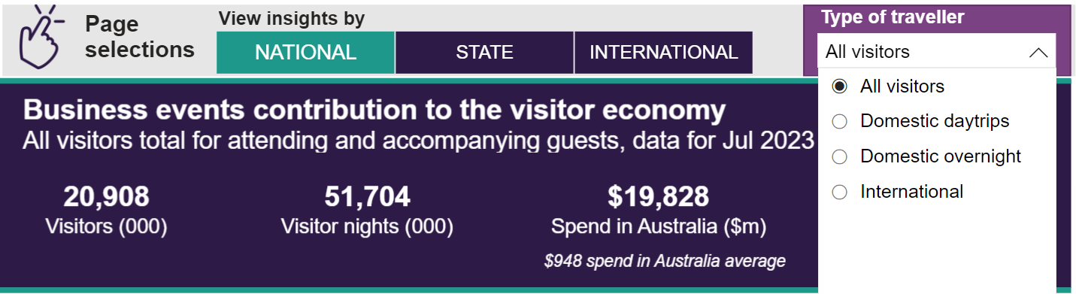

The top section displays a further breakdown for the chosen traveller type who attended business events and those accompanied people who attended business events.

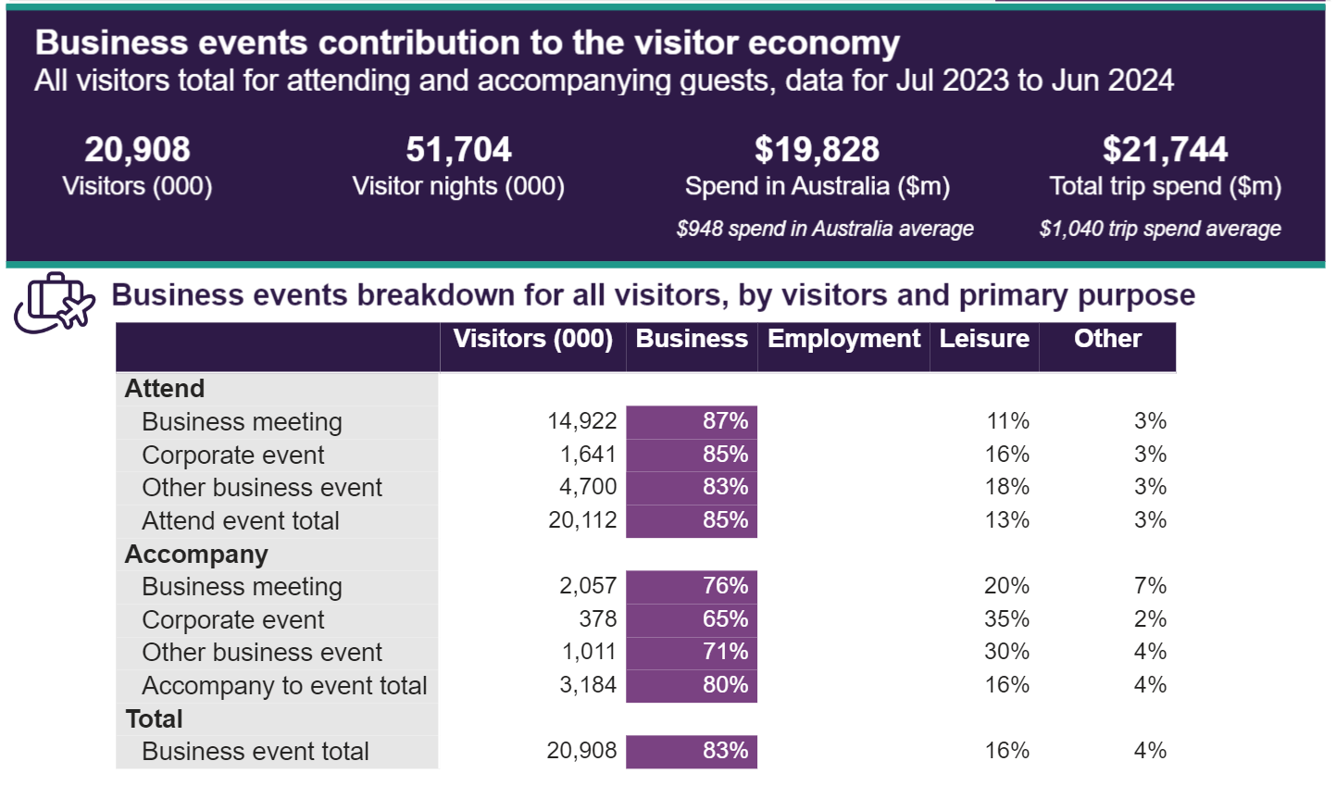

The bottom section allows you to select 4 different themes to display charts and tables:

* Spend items
* Venue
* Travel parties
* Days at events

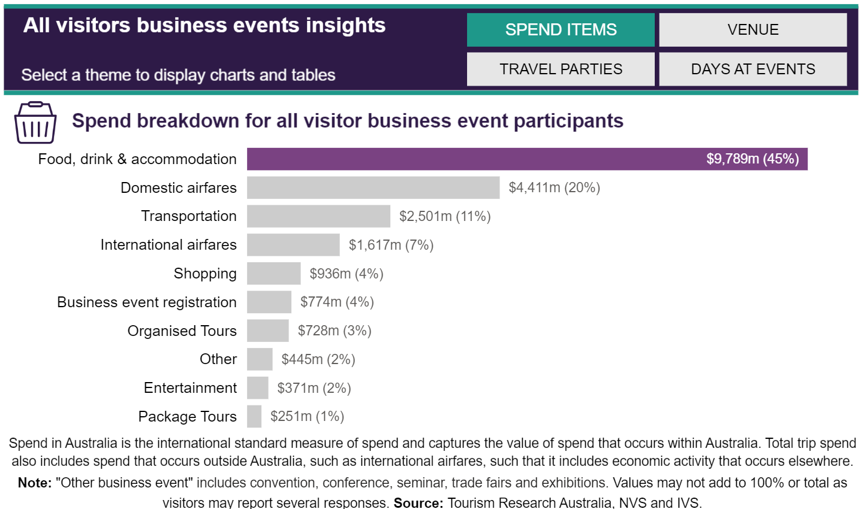

Selecting the State page

The ‘STATE page allows you to select insights for each state and territory (top right drop list):

* ACT
* New South Wales
* Northern Territory
* Queensland
* South Australia
* Tasmania
* Victoria
* Western Australia

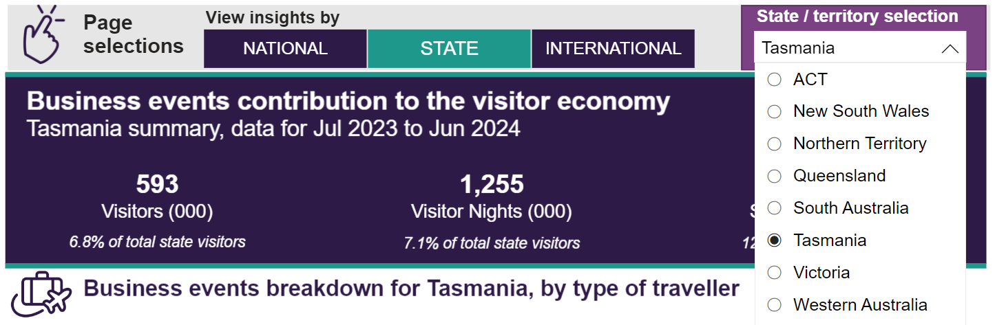

The top section displays a further breakdown for visitors who attended business events and those accompanied for the chosen state/territory.

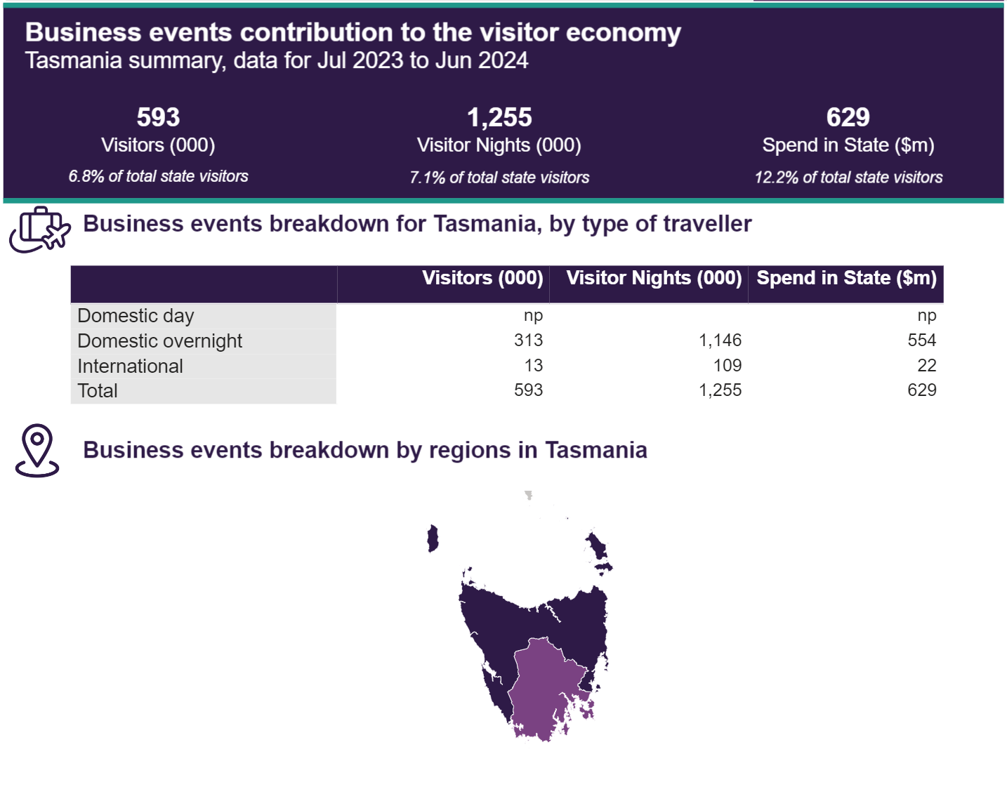

The bottom section allows you view insights at the capital city and regional level for:

* Visitors (000)
* Spend in State ($m)

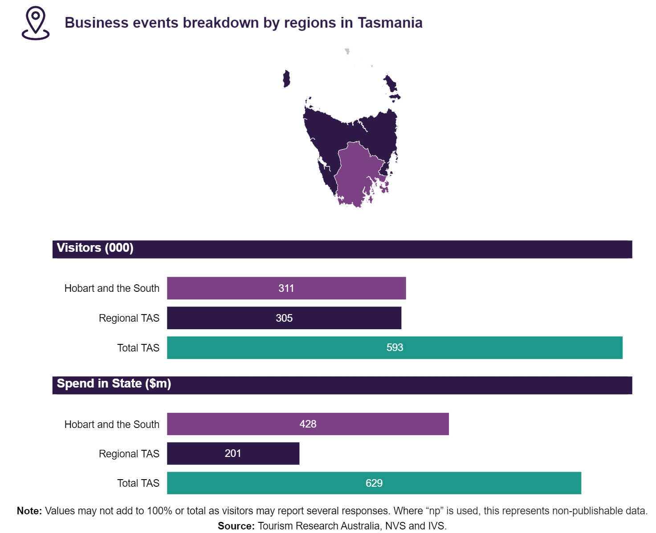

Selecting the International page

The ‘INTERNATIONAL’ page allows you to select insights for international travellers across 4 different measures:

* Visitors (000)
* Visitor nights (000)
* Spend in Australia ($000)
* Total trip spend ($000)

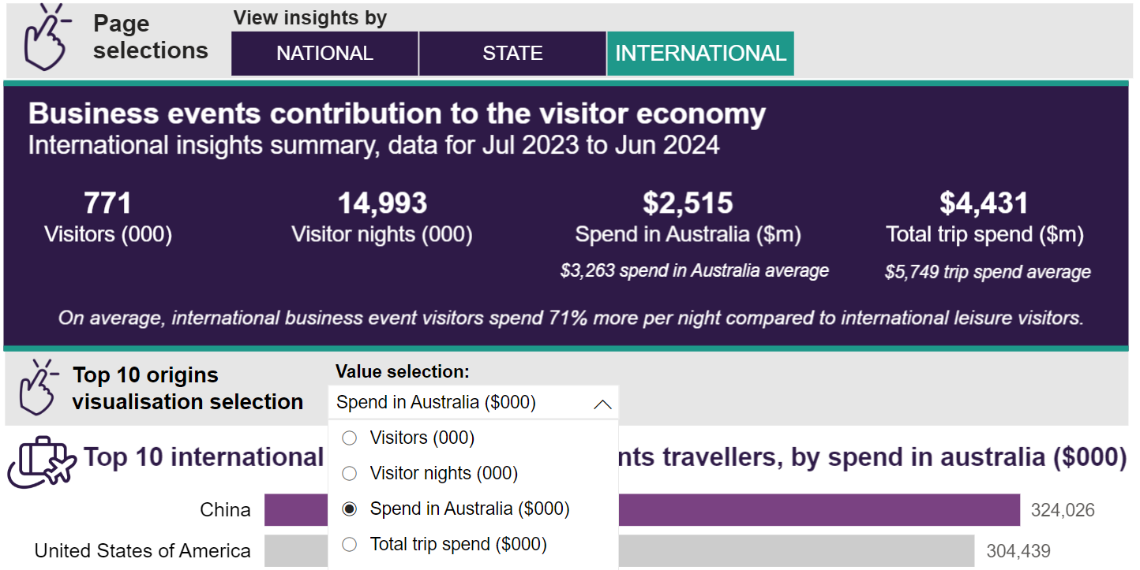

The top section displays the top 10 international origins for business event travellers for the chosen measure.

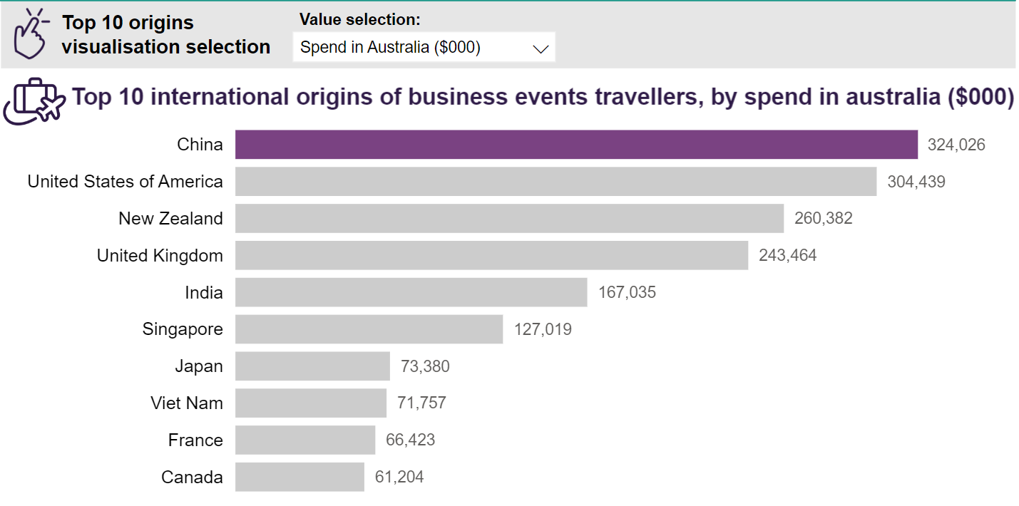

The bottom section shows the top 10 activities engaged international travellers who attended business events or those accompanied.

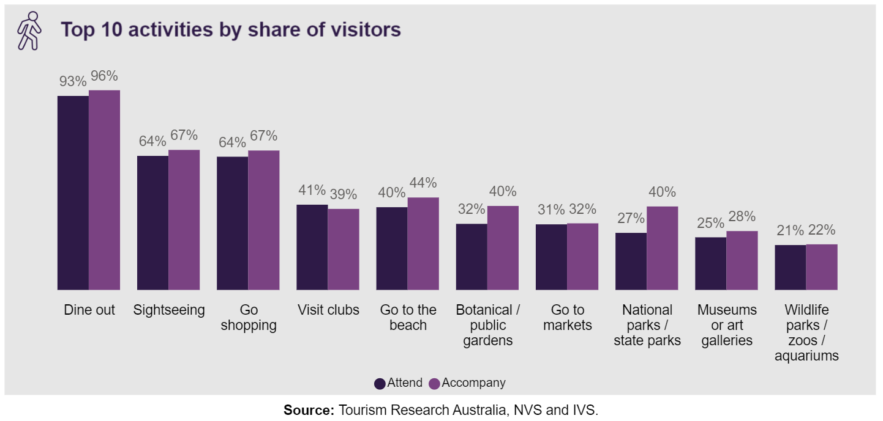

Exporting the report

The visual report can be printed and exported to a PDF. This works best when it is opened in its own window.

1. Navigate to <https://app.powerbi.com/view?r=eyJrIjoiMWE5ZmYzMTEtYjcwZC00MTUyLTlkODktMTEwNThkZjQ0ZmU3IiwidCI6ImM2YmE3ZDI3LWE5N2EtNDBhNC04MmU0LTRkMjMxMzFkZTlmNCJ9>
2. Click within the Power BI frame.
3. Select the print options for your page.
4. If exporting to a PDF, select *Save as PDF* or other PDF options.
5. Under more or advanced setting options, ensure background graphics are enabled. This will ensure all visual elements are exported.

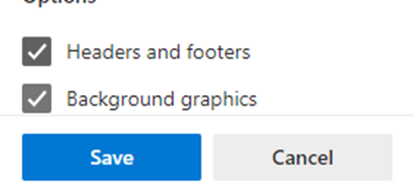

1. Complete the printing or export process.