Know

NATIONAL VISITOR SURVEY RESULTS

MARCH QUARTER 2024

March quarter 2024

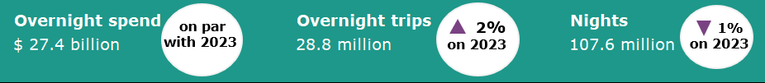

Year ending March 2024
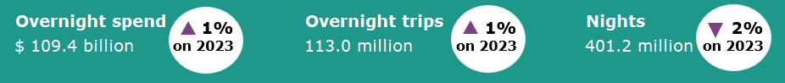

Domestic tourism remained stable
Domestic tourism remained stable in the March quarter 2024 relative to the same quarter a year ago. Spend was flat, trips were up 2% while nights away were down 1% when compared with the March quarter 2023. Strength in travel to capital cities was offset by softer travel to regional areas.
The year ending March 2024 saw a similar pattern of results with spend up 1%, trips up 1% and nights down 2% when compared with the previous year.
The results for the March quarter 2024 and the year ending March 2024 suggest that domestic tourism has stabilised following a challenging period during the pandemic and then an extremely strong initial rebound in 2022 and early 2023.
Figure 1. Percent change for spend, trips and nights compared the same period in the previous year, June quarter 2023 to March quarter 2024

Travelling with Pets
Almost 3 million overnight trips in the March quarter 2024 included travel with a pet. This was up 8% on the March quarter 2023.
Dogs were the most likely to join their owners on an overnight trip (94%) followed by cats (7%).
Of those that reported not bringing a pet on their overnight trip, 7% said this was because they were not allowed to.
Trips including a pet spent less on average ($608) per trip than those that did not include a pet ($995). This is largely as the result of staying in lower cost accommodation such as a holiday home, a friend or relatives property, in a caravan park or camping.
Figure 3: Proportion of nights by accommodation type March Quarter 2024

Travel to capital cities up
Overnight travel to capital cities recorded strong results in the March quarter 2024, compared to the March quarter 2023. Spend and nights away were up 6% and trips were up 2%.
This was offset by softer results for travel to regional Australia. Spend was down 4%, trips were on par and nights were down 5%.
Travellers to capital cities also spent more per trip ($1178) on average in the March quarter 2024 compared to those that travelled to a regional area ($770).
Figure 2: Change in capital city and regional Australia spend, trips and nights, MQ24 compared with MQ23

Family groups support travel in the March quarter 2024
In March quarter 2024, the propensity to travel differed greatly between people in the different stages of life.
Parents with children still living at home (trips up 9%) and older married people (trips up 9%), recorded strong travel results for the March quarter 2024 compared with the March quarter 2023. In contrast older single people (trips down 8%) and young single people (trips down 11%) recorded weaker results in the March quarter 2024 relative to the previous year.
Figure 4: Change in overnight trips by lifecycle stage, MQ 2024 compared to MQ 2023

States and territories
At a state and territory level, results for overnight trips and spend in the March quarter 2024 were mixed when compared with the March quarter 2023 (Figure 5).
Increases in spend in New South Wales (up $259 million or 3%), the Northern Territory (up $229 million or 114%) and South Australia (up $181 million or 11%) were offset by decreases in the other states and territories. Queensland was down $300 million or 4%, Victoria was down $112 million or 2%, the Australian Capital Territory was down $100 million or 19%, Western Australia was down $84 million or 3% and Tasmania was down $28 million or 2%.
Similarly, increases in overnight trips in New South Wales (up 519,000 or 6%), Victoria (up 141,000 or 2%), Tasmania (up 118,000 or 14%), South Australia (up 63,000 or 3%) and the Northern Territory (up 38,000 or 19%) were offset by decreases in overnight trips to the Australian Capital Territory (down 193,000 or 27%), Western Australia (down 124,000 or 4%) and Queensland (down 120,000 or 2%).
Figure 5. Overnight trips and spend by state and territory, March quarter 2024 compared to March quarter 2023
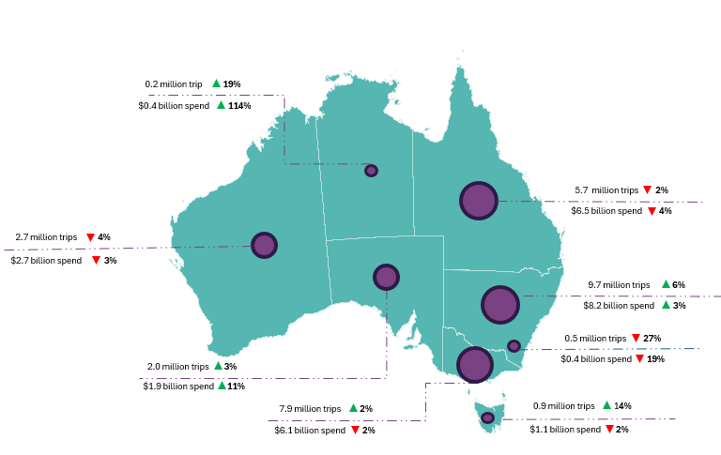
Daytrips
In the year ending March 2024, Australians took 209.3 million daytrips and spent $33.1 billion. Compared with the year ending March 2023 this was:
- down 6.5 million or 3% for trips
- up $1.4 billion or 4% for spend.

This report has been prepared by the Commonwealth of Australia represented by the Australian Trade and Investment Commission (Austrade). The report is a general overview and is not intended to provide exhaustive coverage of the topic. The information is made available on the understanding that the Commonwealth of Australia is not providing professional advice. While care has been taken to ensure the information in this report is accurate, the Commonwealth does not accept any liability for any loss arising from reliance on the information, or from any error or omission, in the report.

