Travel by australians

Year Ending MARCH 2021
OVERNIGHT SPEND |  | OVERNIGHT TRIPS |  | NIGHTS
FIGURE | % | FIGURE | % | FIGURE | %
$45.7 billion | Down 42% | 72.8 million | Down 35% | 281.1 million | Down 31%

MARCH QUARTER 2021
OVERNIGHT SPEND |  | OVERNIGHT TRIPS |  | NIGHTS
FIGURE | % | FIGURE | % | FIGURE | %
$17.9 billion | No change | 24.6 million | Up 1% | 102.1 million | Up 6%

YEAR ENDING MARCH 2021
The year was impacted by border closures and varying restrictions due to the global COVID-19 pandemic. At the height of the pandemic in Australia in April and May 2020, domestic tourism recorded massive losses. Recovery through the second half of 2020 and into 2021 has been slow and affected by snap lockdowns caused by localised COVID-19 outbreaks.
Overall tourism losses for the year ending March 2021 were $82.9 billion. Domestic overnight trips fell 35% to 72.8 million, resulting in a decline in spend of 42% or $33.1 billion to $45.7 billion. Further losses of 35% or $9.1 billion were seen for domestic day travel bringing total domestic tourism losses to $42.2 billion (Table 1). Additionally, following a full year impacted by COVID-19, international travel had losses of 98% or $40.7 billion.

MARCH QUARTER 2021
The signs of improvement seen in December quarter 2020 continued into March quarter 2021. Australians took more overnight trips in the quarter than at any time since the start of the pandemic. This saw a slight improvement on the same period last year which was impacted by bushfires and the beginning of the COVID-19 pandemic. Overnight trips were up 1% to 24.6 million while spend ($17.9 billion) was on par with March quarter 2020.

TABLE 1: AUSTRALIAN TOURISM SUMMARY, Year Ending March 2020 and 2021

spend ($ billions)
 | 2020 | 2021 | LOSS | % Change
Overnight | 78.8 | 45.7 | -33.1 | -42
Day Trip | 25.9 | 16.7 | -9.1 | -35
DOMESTIC TOTAL | 104.6 | 62.4 | -42.2 | -40
INTERNATIONAL ARRIVALs | 41.5 | 0.8 | -40.7 | -98
Total | 146.1 | 63.2 | -82.9 | -57

Visitors (millions)
 | 2020 | 2021 | LOSS | % Change
Overnight | 112.3 | 72.8 | -39.5 | -35
Day Trip | 238.7 | 158.5 | -80.3 | -34
DOMESTIC TOTAL | 351.0 | 231.3 | -119.8 | -34
INTERNATIONAL  ARRIVALs | 8.1 | 0.1 | -8.0 | -99
Total | 359.1 | 231.3 | -127.8 | -36

INTERSTATE and INTRASTATE TRAVEL

Year ending March 2021
COVID-19 related travel restrictions and border closures have stopped nearly all outbound travel and heavily impacted interstate movement in the past year. As a result Australians have switched to taking longer self-drive trips within their home state. In the year ending March 2021, the share of intrastate overnight trips and spend increased across all states and territories. Nationally, the share of overnight intrastate trips increased from 67% to 84% for overnight trips and 44% to 72% for spend.

March quarter 2021
Fewer border closures and an easing of restrictions has seen the interstate market improve in the March 2021 quarter. However, trips were still down 27% to 5.3 million and spend was down 28% to $6.6 billion on March quarter 2020. Comparatively, the intrastate market has seen growth on the same period last year. Overnight trips were up 13% to 19.3 million and spend a higher 30% to $11.3 billion.
Results varied across the states and territories. Due to a combination of snap lockdowns and border restrictions interstate spend was most impacted in Victoria (55% or $918 million loss) and Western Australia (60% or $364 million loss). Intrastate spend was up for all states and territories (see Figure 1).

FIGURE 1: PER CENT CHANGE IN INTERSTATE AND INTRASTATE SPEND BY STATE VISITED, MARCH QUARTER 2021

Capital Cities and Regional Travel

Year ending March 2021
In a year impacted by COVID-19 capital cities have been hit harder than regional areas (Figure 2). During the year ending March 2021, overnight trips to capital cities fell 54% to 21.6 million, more than double the rate of decline in overnight trips to regional areas (24% to 53.6 million). The stronger impact on capital cities was even greater for spend. Spend fell 65% (down $24.6 billion) to $13.5 billion, almost three times the 21% decline (down $8.5 billion) to $32.2 billion in regional areas.
FIGURE 2: CUMULATIVE LOSSES IN DOMESTIC OVERNIGHT TRAVEL, YEAR ENDING MARCH 2021¹
¹ The results of March 2020 were impacted by the start of the COVID-19 pandemic.

March quarter 2021
Regional areas continued to fare better than capital cities through March quarter 2021. Overnight trips to regional Australia were up 12% to 17.8 million and spend a greater 23% or $2.3 billion to $12.0 billion. The stronger growth in spend can be partially attributed to Australians taking longer regional trips on average (up 6% to 4.1 nights). In contrast, overnight trips to capital cities fell 18% to 7.9 million and spend a greater 28% or $2.3 billion to $5.9 billion.
FIGURE 3: PER CENT CHANGE IN OVERNIGHT TRIPS AND SPEND TO CAPITAL CITIES AND REGIONAL AREAS, MARCH QUARTER 2021

REASON FOR TRAVEL

Year ending March 2021
Holiday travel has rebounded better from the height of the COVID-19 pandemic than travel to visit friends and relatives (VFR) or for business. During the year ending March 2021 holiday trips fell 28% to 31.3 million and spend was down 33% to $25.9 billion. VFR trips and spend declined 35% to 24.8 million and 44% to $8.8 billion respectively. Business has struggled most to recover with trips down 49% to 13.4 million and spend 60% to $8.5 billion.

March quarter 2021

Holiday
March quarter results show the stronger recovery in holiday travel. Overall, trips and spend were up 19% and 13% respectively on March quarter 2020. This growth was concentrated in regional Australia and intrastate destinations highlighting the extent to which Australians are currently substituting previous outbound, interstate and capital city holidays with longer length self-drive visits to regional areas close to home.
There were increases of 30% and 33% in overnight holiday visitors to regional areas and intrastate destinations respectively. Growth in holiday spend was even stronger, up 38% for regional areas and 51% for intrastate trips (Figure 4). Comparatively, holiday visitors to capital cities and interstate declined by 11% and 21% and spend was also down 25% and 28% respectively.

Visiting friends and relatives
VFR did not see as strong a rate of growth for regional areas and intrastate travel and the divergence with capital cities and interstate destinations was not as marked. Visitors were up 2% for regional Australia and 5% for intrastate compared with falls of 3% for capital cities and 12% for interstate destinations. Spend increased 10% and 13% for regional areas and intrastate travel but was down 6% and 8% for the capitals and interstate destinations respectively.

Business
Business travel recorded large losses in March quarter 2021, most notably in capital cities and for interstate travel. Overnight trips were down 49% in capital cities and 54% for interstate destinations and spend down a similar 55% and 51% respectively.

FIGURE 4: PER CENT CHANGE IN OVERNIGHT SPEND BY REASON FOR TRAVEL, MARCH QUARTER 2021

TRAVEL MODE
There has been a significant shift in the travel modes used for domestic overnight trips in comparison to the same period in 2020. During the March quarter 2021, domestic overnight trips taken by self-drive vehicle increased in number by 13% to reach 21 million. In contrast trips by air fell 35% to 3.3 million.
Travel by self-drive vehicle accounted for 85% of all domestic overnight trips in the March quarter 2021 up from 76% on the same period in 2020. In contrast, overnight trips involving air travel accounted for only 13% of trips, down from 21% in March quarter 2020.

AccomModation

Year ending March 2021
In a year fully impacted by COVID-19 visitor nights fell 31% (down 123.9 million nights) to 281.1 million for the year ending March 2021. The fall in nights was much larger for capital cities than regional areas. Nights in capital cities fell 52% (down 76.2 million nights), almost three times the 18% decline in nights in regional areas (down 47.5 million nights). Hotels, motels and resorts were the hardest hit in the year ending March 2021, recording an overall 47% fall in nights. This decline was much greater in capital cities, down 66% or 32.8 million nights compared to a 27% or 12.9 million fall in nights in regional areas.

March quarter 2021
In a positive sign, visitor nights were up 6% in the March quarter 2021 in comparison to March quarter 2020, which was impacted by bushfires and the start of the COVID-19 pandemic. During the quarter nights in hotels, motels and resorts were up 1% (or 176,000 nights) to 18.9 million. However, results differed vastly between regional areas and capital cities. Buoyed by increased holiday traffic, nights stayed in hotels were up 35% (or 3.2 million) to 12.2 million in regional Australia. Hurt by lost business and holiday patronage, hotel nights were down 31% or 3 million to 6.7 million for capital cities.
Rented apartments and units and caravan parks and commercial camping grounds fared particularly well in March quarter 2021. Nights were up 20% to 10.9 million for rented accommodation and 16% to 10.6 million for caravan and camping. However, as for hotel accommodation, results differed greatly across capital cities and regional areas (Figure 5).
FIGURE 5: PER CENT CHANGE IN NIGHTS BY ACCOMMODATION TYPE, CAPITAL CITIES AND REGIONAL AREAS, MARCH QUARTER 2021

STATES AND TERRITORIES
With COVID-19 effects from March 2020 onwards, all states and territories had a fall in overnight visitors and spend for the year ending March 2021 (Figure 6).
FIGURE 6: OVENIGHT TRIPS AND SPEND BY STATE, YE MARCH 2021²
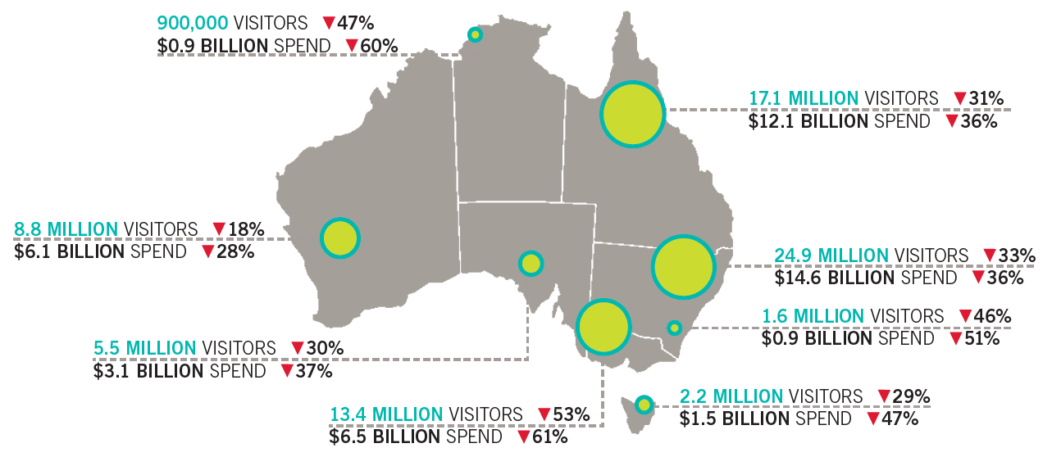
² The sum of the total number of visitors for each state will be greater than the total number of visitors for Australia due to individuals who visited more than one state.

