Australian Tourism in 2020

Introduction
2020 was a year of environmental, epidemiological and economic disruption for Australia’s visitor economy. While Covid-19 dominated global events, the start of 2020 was dominated by some of the most devastating bushfires in Australia’s history.
As the bushfires were finally beginning to be controlled and recovery was in reach, the Covid-19 pandemic took hold. Australia began to restrict arrivals from countries with high Covid-19 cases from February 2020, and closed borders to all international tourists on the 20 March 2020. This was followed by a national lockdown to limit the spread of Covid-19. As a result, the industry faced sharp declines across all sectors, with the deepest impacts occurring in April 2020.
Despite this, tourism experienced a tentative, domestic-led recovery in the months that followed.
Australian tourism is underpinned by a strong domestic sector. For instance, in 2019, 77 per cent of visitor spend came from Australians seeing Australia. This strong domestic demand, combined with our success in limiting the spread of the virus and growth in traveller confidence was critical to tourism recovery.
However, the recovery of tourism was uneven. Some businesses rebounded relatively quickly, while others faced prolonged downturns. Factors affecting business recovery included:
- location and business activities
- reliance on international tourists
- outbreaks of Covid-19 and resultant lockdowns
- effectiveness of Covid-safe restrictions.
These factors led to additional challenges for businesses that had already faced difficulties because of bushfires and lockdowns. Many relied on JobKeeper to remain operational.
The events of 2020 and their unparalleled impacts on Australia’s visitor economy are complex, and in some cases, long lasting. This report looks back on what happened during the year, the impacts to the different parts of the visitor economy, and the challenges currently being faced by the industry.

A devastating bushfire season
The start of 2020 was dominated by some of the worst bushfires in Australia’s history. Australia suffered loss of life, damage to property, and devastation to wildlife and natural landscapes.
The bushfires were reported extensively by international media, with 80 per cent of coverage featuring photos and videos. While these elicited sympathy and donations from across the globe, it also led to perceptions that the bushfires were more widespread than they actually were, damaging Australia’s reputation as a pristine tourism destination.
In reality, the bushfires spanned 110 of Australia’s 537 local government areas and burnt 6 per cent of Australia’s forest, with varying impacts across Australia’s states and territories. States and territories most affected included:
- New South Wales – 25 per cent of total forest area burned
- Victoria – 18 per cent of total forest area burned
- The Australian Capital Territory – 58 per cent of total forest area burned.
Table 1 – Impact of 2019 and 2020 bushfires on State and Territory forests
State | Total forest hectares burnt | Proportion of total forest area burnt
New South Wales | 5,123,000 | 25%
Victoria | 1,457,000 | 18%
Western Australia | 1,144,000 | 6%
Queensland | 514,000 | 1%
South Australia | 137,000 | 3%
Australian Capital Territory | 83,000 | 58%
Tasmania | 30,000 | 1%
Northern Territory | 0 | 0%
Total | 8,488,000 | 6%
(Source: Department of Agriculture, Water and the Environment, Forest fire data, accessed June 2021)
Figure 1 – Bushfire impact by local government areas 2020
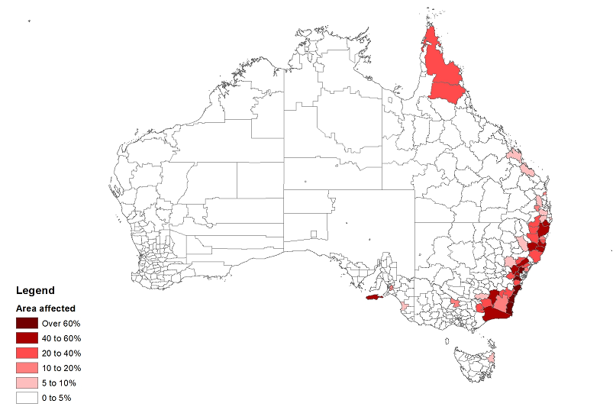
(Source: National Recovery and Resilience Agency, Local Area Profiles for 2019-20 Bushfires, accessed May 2021)
From the perspective of Australia’s visitor economy, the fires had the greatest impact in the following ten tourism regions:
- North Coast (NSW)
- South Coast (NSW)
- Central Coast (NSW)
- Blue Mountains (NSW)
- Snowy Mountains (NSW)
- High Country (Victoria)
- Lakes (Victoria)
- Kangaroo Island (SA)
- Adelaide Hills (SA)
- Canberra (ACT)
Impacts on tourism differed widely between these regions. Some regions experienced minimal falls in spend. Factors impacting demand include:
- the duration and severity of the fires
- proximity to population centres
- whether the fires coincided with peak holiday periods
- access to alternative tourism destinations within the region.
To illustrate this, in the March quarter 2020 when holiday travel would have been at its peak, visitor spend varied from March 2019 as follows:
- High Country (Victoria) – down 29 per cent ($89 million)
- South Coast (NSW) – down 23 per cent ($251 million)
- Kangaroo Island (SA) – down 13 per cent ($9 million)
- Canberra – down 10 per cent ($56 million)
- Central Coast (NSW) – down 7 per cent ($23 million)
- Snowy Mountains (NSW) – down 6 per cent ($7 million)
- Blue Mountains (NSW) – down 2 per cent ($4 million)
- North Coast (NSW) – down 0.1 per cent ($1 million)
- Lakes (Victoria) – up 13 per cent ($20 million)
- Adelaide Hills (SA) – up 14 per cent ($7 million)
While the fires significantly altered the travel plans of some Australian travellers during the peak holiday season, there were no immediate impacts on overseas demand. For instance, at the peak of the fires in December 2019 and January 2020 there were 1.8 million international short term visitor arrivals, a 3 per cent increase over the same months in the previous years. It is likely that overseas demand held up over this period because:
- overseas trips are planned well in advance
- cancellations are expensive
- overseas visitors mainly visit capital cities, which, aside from instances of smoke haze from surrounding regions, were relatively unaffected. In 2019, 93 per cent of international tourists visited capital cities, compared with 33 per cent visitation to regional destinations.

A sudden halt in international visitors
International disruption from Covid-19 started on 1 February 2020 when Australia closed its border with China in line with recommendations by Australia’s chief medical officer. As the pandemic began to spread, travel was blocked from Iran (29 February 2020), South Korea (5 March 2020) and Italy (11 March 2020), before international borders closed to all arrivals except Australian citizens and permanent residents on 20 March 2020. Hotel quarantine became mandatory for all overseas arrivals from 28 March 2020.
The result of these border closures was a rapid fall in short term visitor arrivals in February 2020. Visitor arrivals fell further through March 2020 before flat-lining at historically low levels from April 2020 onwards.
The impacts of the sudden loss of international visitors were felt immediately, especially by parts of the industry that had a high reliance on international tourism. These included the events and aviation sector, travel agencies, tour operators and cruise lines.
Figure 2 – Short term visitor arrivals in 2020 compared with corresponding period in 2019
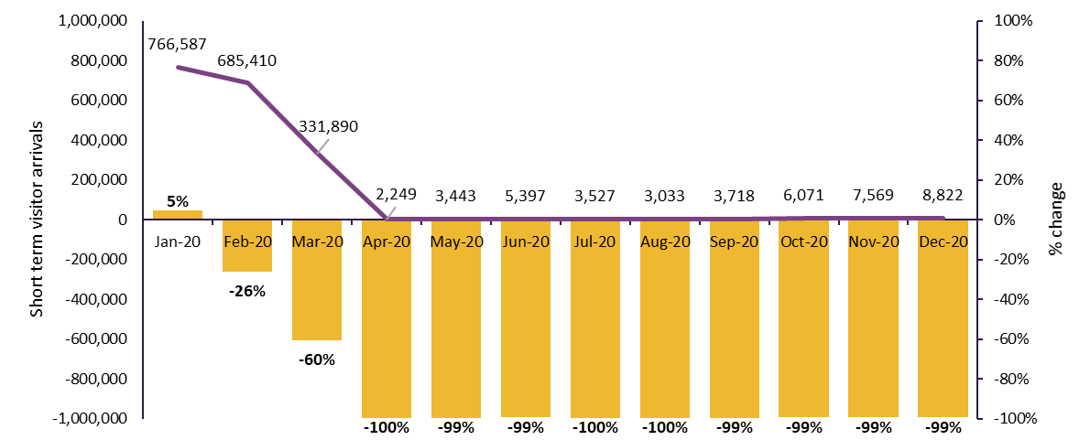
(Source: Australian Bureau of Statistics, Overseas Arrivals and Departures, Australia, accessed June 2021)

Impact on Airfreight
The freeze on international visitors and resultant halt of international flights had a devastating flow-on affect to global trade. Before the pandemic, over 80% of Australia’s airfreight was carried in the cargo hold of passenger aircraft with the remaining 20% carried by dedicated cargo aircraft. The sudden cessation of international passenger movements meant that exports such as animal products, vegetable products, beverages and gold were at risk, especially to Asian markets.
(Source: Infrastructure Partnerships Australia, 2019 International Airfreight Indicator, accessed June 2021)
The Australian Government’s International Freight Assistance Mechanism (IFAM) was established to keep global air links open in response to the Covid-19 pandemic. Since April 2020, IFAM has reconnected 9 Australian ports to 58 international destinations and helped the movement of high-value perishable Australian products reach existing international customers. The program has also enabled the import of nationally important goods, aiding Australia’s pandemic response. IFAM has helped protect hard fought market share for Australian businesses, while providing them with time to align their operating models to ‘new-look’ supply chains.
The downturn in international visitors impacted the industry in different ways. There was particular concern for businesses in bushfire-affected regions that had already faced prolonged loss of income, and in many cases had missed out on their peak holiday season. Domestic and international visitation to Australia’s gateway cities of Sydney, Melbourne, Brisbane and Perth slumped as international tourism came to a standstill, and sporting and business events were cancelled. Internationally connected regional destinations were also highly vulnerable, with some hotels advertising rooms at half the normal price.
Table 2 – Reliance on international tourism for selected regions, 2019
Region type | Region name | Total spend in 2019 ($m) | Share of spend from international
Regions with over 20% reliance on international spend – 10 regions | Sydney | 22,814 | 45%
 | Melbourne | 20,336 | 40%
 | Lasseter | 539 | 34%
 | Kangaroo Island | 191 | 28%
 | Tropical North Queensland | 3,964 | 26%
 | Gold Coast | 5,937 | 23%
Regions with 10 – 20% reliance on international spend – 8 regions | Whitsundays | 808 | 19%
 | Hobart and the South | 2,192 | 17%
 | Alice Springs | 434 | 15%
 | Litchfield Kakadu Arnhem | 267 | 12%
 | Australia's Coral Coast | 936 | 14%
Regions with under 10% reliance on international spend – 58 regions | South Coast NSW | 3,257 | 8%
 | Central Highlands | 199 | 8%
 | Blue Mountains | 796 | 7%
 | Great Ocean Road | 1,576 | 7%
 | North Coast NSW | 5,174 | 5%
 | Mackay | 658 | 3%

Industry and Government were quick to react. The Commonwealth Government announced the $1 billion COVID-19 Relief and Recovery Fund which rolled out a series of support measures for the industry including:
- the Recovery for Regional Tourism Program ($50 million)
- the Zoos and Aquariums support program ($95 million)
- the Business Events Grant program ($50 million).
This was in addition to the $76 million allocated for bushfire recovery in the tourism sector. Whole-of-economy measures such as the JobKeeper wage subsidy and boosting cash flow for employers programs were also highly utilised by the tourism industry.
The sectors that were immediately affected were those reliant on international leisure travel. In 2019, holidaymakers accounted for 33 per cent of all international spend in Australia, with travellers who visit friends and relatives contributing another 13 per cent. While education accounts for a large share of international spend (39 per cent), the impacts took longer to materialise because:
- the majority of international students were already in Australia when the pandemic hit
- students were able to stay in Australia until the completion of their studies
- outbound flights from Australia were limited, making it difficult for students to return to their home country.
At the end 2020 there were still 386,000 student visa holders in Australia.
(Source: Home Affairs, Student visa holders by location, accessed June 2021)

The impact on international education
There is an overlap between international education and tourism. International students are counted as part of Australia’s Visitor Economy if their stay in Australia on any given visit is less than 12 months. Therefore, it will include students taking short courses in Australia as well as those doing longer courses but returning during academic breaks.
Prior to Covid-19, Australia enjoyed consistent international student growth from 2013. In 2020, enrolments fell by 7.3 per cent to 882,482 (down 69,789), but this was 10,158 more enrolments than in 2018. Enrolments held up due to various factors:
- At the time of border restrictions in March 2020, most international students (81 per cent) were already in Australia.
- Enrolment growth in VET (up 25,958) helped offset declines in key markets. It was the only sector to experience growth, appearing to be an attractive option to upskill and/or remain in Australia as a student.
- Institutions developed online courses for enrolled students that were outside Australia. While many students have undertaken these online courses, others have decided to defer their studies to a later date.
Figure 3 – International enrolments and commencements, 2013 to 2020

New enrolments were hard hit in 2020, declining by 21.9 per cent on the previous year to 398,958. All sectors experienced declines, with English language intensive courses for overseas students (ELICOS) falling the most. Declines in ELICOS are likely to impact other sectors eventually, due to its importance as a pathway to further study. Two thirds of students who completed an ELICOS course in 2019 undertook subsequent study in another sector.
A year on from the border restrictions the proportion of student visa holders onshore has fallen to 68 per cent. Given students’ preference to undertake courses face-to-face, industry feedback suggests that – due to border uncertainty – individuals keen to (re)commence their studies are considering other study destinations.

National lockdown – the lowest point for tourism
In order to limit the spread of Covid-19, Australia entered into a national lockdown to ‘flatten the curve’ in April 2020. Australians were urged to stay at home unless it was absolutely necessary to leave the house. Acceptable reasons were limited to work, school, buying essentials, medical care and exercise. A number of other restrictions were enforced including limitations on gatherings, mobility restrictions, social distancing requirements, and strict capacity limits on venues and business premises. Services that were considered non-essential were also limited. Examples of closures included:
- food and drink businesses being limited to takeaway or home delivery
- entertainment venues such as cinemas, nightclubs and amusement parks closing
- cultural experiences such as galleries, museums and historic sites closing.
(Source: Prime Minister of Australia, Media statement, statement made 24 March 2020)
State governments applied the national health directives in different ways. Except for limited movement between New South Wales, Victoria and the Australian Capital Territory all other states and territories closed their borders to limit the spread of the virus.
As expected, lockdowns had a devastating impact to tourism. April 2020 became the most severely impacted month.
- There was a 91 per cent drop in visitor spend (loss of $10.7 billion).
- There was a 99 per cent drop to international visitor spend (loss of $1.9 billion).
- There was a 97 per cent drop in domestic flight passengers (fare paying).¹
- Hotel occupancy fell to just 20 per cent with many businesses going into hibernation.²
- Consumer sentiment hit a low point (19 per cent drop compared to January 2020).³
- Only 29 per cent of people intended to travel in the 6 months following April 2020.⁴
- More than half of Australians wanted to travel domestically once restrictions were lifted.⁵
The shock to tourism was felt globally, with international tourist arrivals dropping by 97 per cent, and global hotel occupancy rates falling to 22 per cent (April 2020) ⁶.
(Source 1: Department of Infrastructure, Transport, Regional Development and Communications, Domestic aviation activity, accessed June 2021)
(Source 2: STR, Australian Accommodation Monitor, financial year 2019–20)
(Source 3: Melbourne Institute, Westpac-Melbourne Institute consumer sentiment index, accessed April 2021 via RBA)
(Source 4: Tourism Australia, Domestic Travel Sentiment Tracker, accessed March 2021)
(Source 5: The University of Queensland, Sunny outlook for domestic tourism post COVID-19 restrictions, accessed June 2021)
(Source 6: UNWTO, UNWTO Tourism Recovery Tracker, accessed April 2021)
Some businesses were able to use the lockdown as an opportunity to renovate their properties.
The Vinegrove, a popular wedding destination in Mudgee, was forced to postpone bookings during peak period. Owners Sarah and Tim Ferris said: “We’re painting those things that need painting and fixing up, propping up, and just making everything better again”.
(Source: SBS, After drought and bushfires, coronavirus is impacting tourism in Australia's regions, accessed May 2020)
However, not all businesses were in this position, with some new hotel openings postponed due to lack of financial viability.
Crowne Plaza Sydney Darling Harbour was expected to open in May 2020,however did not open until September 2020.

The beginnings of a domestic-led tourism recovery
Closure of international borders meant Australia’s visitor economy relied on domestic travellers to lead the recovery. Australia's success in containing Covid-19 allowed for mobility – albeit with restrictions – facilitating the restart of domestic tourism.
Australia was fortunate in this respect. Australians are keen travellers with 77 per cent of all visitor spend in 2019 coming from domestic travel. This share is even higher for regional destinations where domestic tourism accounts for more than 90 per cent of all visitor spend. The industry also sought to capture domestic travellers that would have holidayed overseas. In 2019, Australians spent $65 billion travelling overseas, with $43 billion of this being for a holiday.
Instrumental to the return of domestic travel was the three stage CovidSafe roadmap to recovery announced by the Prime Minister in May 2020. Stage one included:
- local and regional travel
- increases in visitors allowed at home and in businesses
- encouraging people to continue working from home unless it wasn’t feasible
- restaurants, cafes and shopping centres being allowed to open.
Stage 2 included interstate travel and the opening of caravan and camping grounds. Stage 3 included full interstate travel, and considerations on Trans-Tasman, Pacific Island and international students travel.
Implementation of these stages was the responsibility of state and territory governments. This saw interstate borders closing and reopening at different stages to keep localised outbreaks under control and minimise the risk of infections from other jurisdictions. These actions became a heavily debated topic – particularly within the tourism industry. Many industry leaders urged state and territory governments to adopt a more risk-based and consistent approach to border management that considered both economic and public health concerns.
(Source: COVIDSAFE, Roadmap to a COVIDSafe Australia, accessed June 2021)

Domestic tourists have different travel patterns to international tourists
Although the recovery was led by domestic tourists, travel and spend patterns of domestic tourists are vastly different to those of international visitors. The average domestic overnight trip is less than four nights and average spend is under $700. By comparison, the average trip for an international tourist is 18 nights, with spend of $6,500.
Domestic trips are concentrated in weekends, with spikes in demand around long weekends and school holiday periods. Demand from international visitors is spread more evenly, meaning they play an important role in supporting businesses during non-peak periods. The chart below shows the cyclical nature of domestic overnight leisure trips compared to the relatively stable flow of international visitors.
Figure 4 – Domestic overnight leisure trips versus international leisure trips, 2019
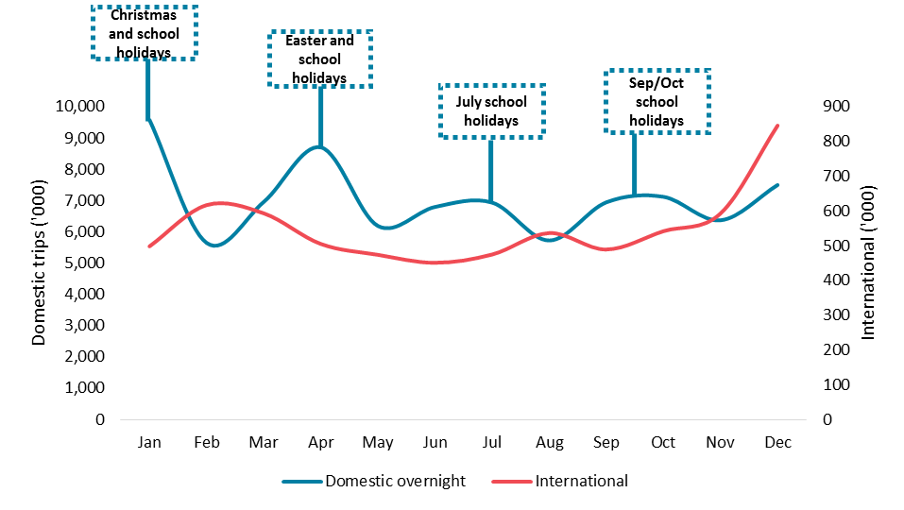
Other critical factors that are different between domestic and international visitors include:
- More than 50 per cent of domestic spend goes to regional areas (compared to just 14 per cent for international visitors).
- Domestic trips are nearby, with almost 70 per cent of domestic overnight travel intrastate.
- Domestic travellers are likely to only visit one location per trip – just 10 per cent visited more than one destination on their trip.
- Domestic trips are also shorter with 57 per cent of trips only one or two nights.
- Domestic travel is weekend centric – 47 per cent of all domestic overnight trips returned home on Sunday or Monday. This increases to 57 per cent when considering just holiday trips.
- Domestic visitors have less reliance on commercial travel options, with 73 per cent travelling by car. While domestic overnight visitors have a lower reliance on aviation (24 per cent of trips), they currently account for 84 per cent of trips on planes.

Challenges for a domestic led recovery
The environment in which Australia’s visitor economy operated in 2020 was very different from other years. As a result, domestic recovery was disrupted and challenged by several key factors:

Restrictions on trade
For much of 2020, businesses were operating under strained circumstances. Venues had capacity restrictions, restaurants only offered takeaways, flights were reduced, attractions were closed and many hotels went into hibernation. These factors made planning travel difficult, undermined confidence, reduced choices for consumers and detracted from the overall visitor experience. Interstate trips were especially difficult to plan due to snap border closures and the resultant cancellation and reinstatement of flights.
Sudden border closures not only had severe impacts to tourism businesses, they also took an emotional toll on travellers. In November 2020, Western Australia suddenly closed borders with South Australia in response to the Covid-19 outbreak originating from the Woodville Pizza Bar. Passengers on a flight from Adelaide to Perth were told they had to go into two weeks’ quarantine on arrival, despite the WA government only hours earlier assuring South Australians they could enter the state without having to isolate.
<<MEDIA BOX>>
Travellers from Adelaide to Perth on Sunday night broke down in tears as they were told mid-flight they would not be allowed to enter WA, and would need to pay for quarantine or turn around. The passengers — who included a jewellery tycoon and a grandmother who hadn’t seen her grandchildren for a year — were excited to make the trip, with the border opening just 48 hours earlier. But as the flight took off, three locally transmitted cases were announced in South Australia, forcing Western Australia to slam its border shut — even to those already en-route.
South Australian businessman Albert Bensimon, who was on a Perth-bound flight, told NCA NewsWire a few people “broke out in tears” when they heard the news. “I don’t think they either had the money to fly back or to pay for quarantine for 14 days or perhaps they were unhappy they couldn’t see their loved ones,” the Shiels Jewellers owner said.
Travelling over for business, Stefan Ahrens of Gilberton said he was on-board Sunday’s flight to Perth and was told about the border closure once he landed. The 52-year-old said passengers were given an ultimatum: to quarantine for 14 days or return to Adelaide. He chose the latter. “We landed and were about to get off but nobody knew what was going on and they asked us to stay still,” Mr Ahrens said. “Then they said they’d take us off the plane and put us in a separate lounge for an hour or two and told us we had two options.
(Source: The Australian, Travellers ‘broke out in tears’: Inside flight from Adelaide to Perth turned around at airport, accessed June 2020)
<<END BOX>>

The slow return of interstate travel
In 2019, interstate travellers accounted for 37 per cent of all domestic spend, and spent an average of $779 per trip. This was almost four times what was typically spent on intrastate trips. Interstate travellers are also more likely to stay in commercial accommodation, eat at restaurants, catch a plane and participate in tourism experiences. For example:
- 62 per cent of overnight interstate trips included commercial accommodation, compared with 41 per cent of overnight intrastate trips.
- 61 per cent of overnight interstate trips involved air travel (24 million trips), compared with only 6 per cent of overnight intrastate trips.
However, border closures, health concerns and reduced aviation capacity all played a part in slowing the recovery of this important sector. By December 2020, spend on interstate trips had recovered to $1.7 billion, 42 per cent below the pre-pandemic spend of $2.9 billion.
Figure 5 – Intrastate spend vs interstate spend, April to December 2020
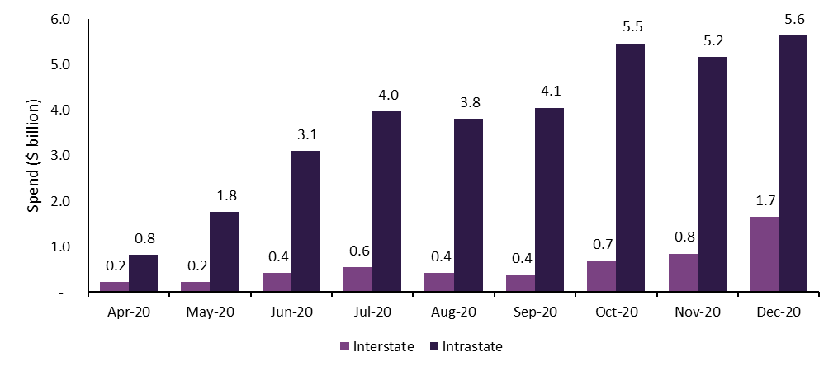
<<START BOX>>
The gradual opening of state borders in the latter half of 2020 led to reinstated flights being booked out within minutes and immediate spikes in accommodation bookings.
When Queensland opened borders in July 2020 following an extended closure, travellers were cheering and waving as they crossed into the state. Many travellers tried to enter Queensland illegally before the mid-day border reopening, with 700 vehicles being turned away.
(Source: Courier Mail, Heavy traffic as Queensland reopens to interstate travellers, accessed July 2020 through 9AM GM Daily News)
<<END BOX>>

Ongoing health concerns
The fear of contracting Covid-19 was a concern faced by many Australians in 2020 and a significant travel disruptor. In a Tourism Australia survey questioning the main barriers to domestic travel, respondents consistently stated they were afraid of contracting Covid-19 – a similar disruptive effect to mandated travel restrictions. This fear of catching the disease peaked during the Covid-19 outbreak in Victoria (July to September 2020). In the months of August and September 2020, almost half of all respondents expressed this fear. This was despite case numbers in other states and territories being at far lower levels.
Figure 6 – Tourism Australia survey on barriers to travel, April to November 2020
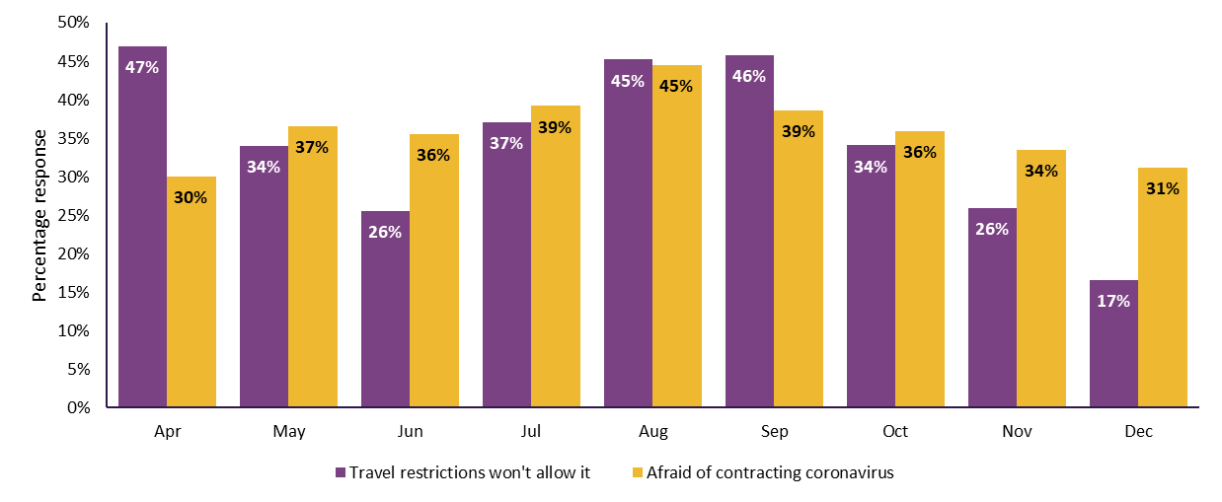

Consumer sentiment
Common to all border closures was a disruption to travel plans and the possibility that consumers would lose money paid in advance to tourism operators. In the early stages of the pandemic these financial risks as well as health risks and restrictions weighed heavily on consumer sentiment.
As the year progressed, there was greater understanding about how Covid-19 was transmitted as well as improved contact tracing. As a result, border closures and lockdowns became shorter, more targeted and more decisive. For example, in November 2020 South Australia entered a 6-day lockdown in response to an outbreak of Covid-19. When further information came to light, the lockdown was shortened by 3 days.
One positive impact of this greater understanding was that people became more confident in planning and booking trips. In April 2020, 60 per cent of participants in a Tourism Australia survey said they were not thinking about their next holiday. This was an all-time low for this measure. Sentiment improved through the year such that by December 2020 only 38 per cent were not thinking about their next holiday.
Figure 7 – “Which of the following best describes your thinking around your next holiday”, Tourism Australia Survey of travel sentiment, April to November 2020
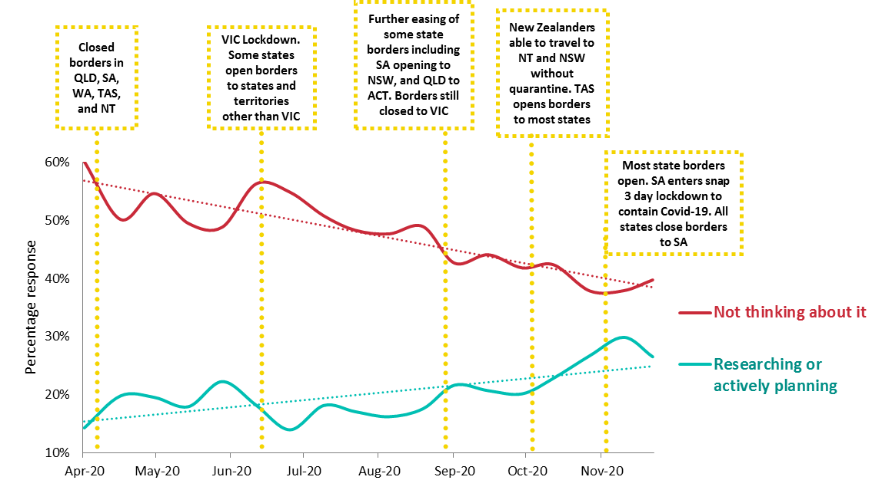

Recovery of internationally reliant regions
International tourism made up less than a quarter of all visitor spend in 2019 – however its significance varied widely across Australia. In 2019, 35 per cent of all visitor spend in capital cities came from international tourists. This was highest for gateway cities such as Sydney and Melbourne (45 per cent and 40 per cent of spend coming from international). Away from the capitals, international tourism features strongly for the Gold Coast (23 per cent), Lasseter (34 per cent), Kangaroo Island (28 per cent) and Tropical North Queensland (26 per cent).
A region’s reliance on international visitors was a key factor affecting the speed of recovery. Regions that had a lower reliance (under 15 per cent of spend) on international leisure tourism experienced a faster recovery than others. All regions experienced on average a 96 per cent drop in leisure spend in April 2020 compared with the equivalent month in the previous year. However, by December 2020, regions that had a high reliance on international leisure spend were still down 51 per cent, whereas other regions were down 39 per cent.
Figure 8 – Leisure spend, regions with high international reliance versus other regions, February to December 2020
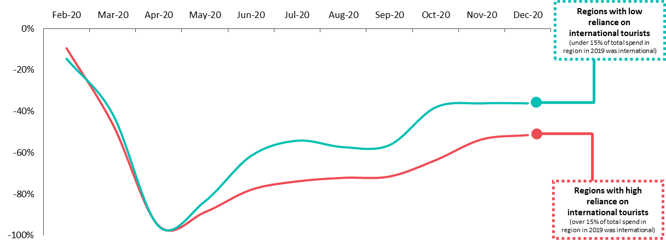

Shape of domestic recovery
Domestic tourism started to recover from May 2020. Day trips rebounded more quickly than overnight trips as they need less planning.
However, recovery of both day and overnight trips was disrupted by lockdowns and border closures. The most notable of these occurred in July 2020 during the outbreak of Covid-19 in Victoria. While spend on day trip travel rebounded quickly, the recovery of domestic overnight travel was slower.
This reflected consumer sentiment. During the period July to September 2020, travel restrictions and fear of contracting Covid-19 were considered the top barriers to travel.
These sentiments along with pent-up demand also saw regions within a 2 to 3 hour drive of capital cities recovering faster than other regions. During peak periods, businesses in these regions had phones ringing off the hooks, with occupancy rates higher than pre-pandemic levels. Unfortunately, with volatile state border closures, and the resulting cancellation and resumption of flights, remote regions that relied on air travel continued to suffer.
Figure 9 – Change in domestic day trip spend, 2020 versus corresponding period in 2019

Figure 10 – Change in domestic overnight spend, 2020 versus corresponding period in 2019

Business performance
When Covid-19 hit, the tourism industry experienced the effects immediately. In March 2020, 78 per cent of businesses in the accommodation and food services sector reported that they were experiencing adverse impacts of Covid-19. This was 29 per cent higher than the average for all industries of 49 per cent. The arts and recreation sector had similar results, with a 73 per cent experiencing adverse impact. The pronounced impact of the pandemic on these two sectors was evident throughout the months of 2020.

Contributing factors
The difficult experiences faced by the industry came from a combination of factors.
The nature of tourism – Tourism is dominated by service-oriented businesses that are based on person-to-person interactions. This made businesses highly vulnerable to the effects of travel restrictions, capacity constraints, social-distancing and the increased health risks from interacting with other people. In April 2020, 84 per cent of businesses in the accommodation and food services sector, and 94 per cent in the arts and recreation services sector said that they anticipated government restrictions would have adverse impacts on their business. These sectors were ranked the worst affected, with the national average being just 53 per cent.
(Source: Australian Bureau of Statistics, Business Conditions and Sentiments, reference period – April 2020)
Tourism businesses are predominantly small – There are over 300,000 tourism businesses in Australia – with almost 80 per cent having fewer than 5 employees and over half having an annual turnover of less than $250,000. Being small in scale, and having low cash reserves, meant many of Australia’s tourism businesses were especially sensitive to the economic shocks of 2020, which still resonate today.
Tourism is not an essential activity – Demand increases for non-essential activities during more buoyant economic times when consumer confidence is high. The downside of this is that demand for tourism products is likely to decrease when the economic outlook is more pessimistic and employment is uncertain. Concern about current and future financial circumstances was a consistent fear people expressed when asked why they were not likely to travel within Australia in the near future.
Figure 11 – Tourism Australia survey on the financial barriers to travel, April 2020 to February 2021

Tourism is highly segmented – The decline in tourism demand was uneven. Therefore, businesses which focused on the interstate, international or business traveller markets were more severely impacted. Airlines, accommodation providers, inbound tour operators and car rental firms are examples of these types of businesses.
Business travel may be slow to resume – Employers scaled back business trips in 2020 because of travel restrictions and traveller safety. This is likely to continue due to the wide acceptance of videoconferencing as a viable way of doing business. This technology also has the advantage of being cheaper, more convenient and less disruptive than business travel.
In 2020, spend on domestic overnight business trips for Australia’s capital cities fell 71 per cent. This shortfall in business travel cannot be replaced easily from other sectors. Business travel is primarily a weekday market that complements weekend demand from leisure travellers.
The decline in business travel also had a flow-on effect for the business events industry, which comprises meetings, incentives, conventions and exhibitions. This industry may be one of the last industries to recover due to the long lead times between booking and actually holding a business event. A survey conducted by the Business Events Council of Australia found that 61 per cent of business events businesses saw a 75–100 per cent reduction in turnover for 2020 compared to 2019, while 44 per cent forecast the same result for the 6 months to June 2021.
(Source: Business Events Council of Australia, Government Support and Future Confidence Report 2021, accessed June 2020)
<<START BOX>>
During the Victorian lockdown, Daylesford Hotel owner Anne-Marie Banting described the situation as “My business partner and I have been taking it in turns to cry. One day one of us is crying, the next day the other is crying … We've absolutely just lost our biggest market. It could be that we have to shut the hotel down. Again. Go into hibernation.”
(Source: ABC, Regional Victorian tourism 'on its knees' after second Melbourne lockdown, with fears it'll cost $350m, accessed June 2021)
Geelong accommodation provider Lon Retreat & Spa in Point Lonsdale faced 150 cancellations forcing the closure of the hotel side of the business in August 2020. Owner Claire Gemes said “It was looking to be the busiest we’ve ever been, even busier than summer…We put all the groundwork in for those bookings, we invested in staff, food and supplies to reopen, and some of that just can’t be recouped. “That’s difficult and disappointing for us — it’s a big financial and mental hit.”
(Source: Geelong Advertiser, Geelong tourism to suffer massive blow with Melbourne in lockdown, accessed through 9AM GM Daily News)
<<END BOX>>

The tourism workforce
The tourism workforce fell substantially throughout 2020. At the end of the year there were 664,000 filled tourism jobs, 80,500 fewer than in December 2019. This represented a 10.8 per cent fall in employment and compared poorly with the 2.0 per cent decrease for the workforce as a whole.
Within tourism, the most pronounced falls were in air, water and other transport – a jobs decline of 40.9 per cent or 17,300 jobs over the year. Job losses were experienced by airlines, airports, and other businesses that rely on airline operations. There was a 22.8 per cent fall in accommodation jobs as many hotels and motels closed or went into hibernation.
(Source: Australian Bureau of Statistics, Tourism Satellite Accounts: quarterly tourism labour statistics, Australia, experimental estimates, December 2020 release)
However, the loss of tourism jobs was not as severe as the decline in tourism demand. This was mainly because employers were able to use the JobKeeper wage subsidy to retain workers throughout the year.

The pandemic also accelerated structural changes to the industry. Traditionally, the number of full-time tourism jobs has exceeded part-time. As the tourism industry has grown, the share of part-time jobs in the visitor economy has slowly increased; however in September 2020 part-time jobs overtook full time jobs for the first time.
Figure 12 – Tourism employment and tourism spend, December 2019 to December 2020
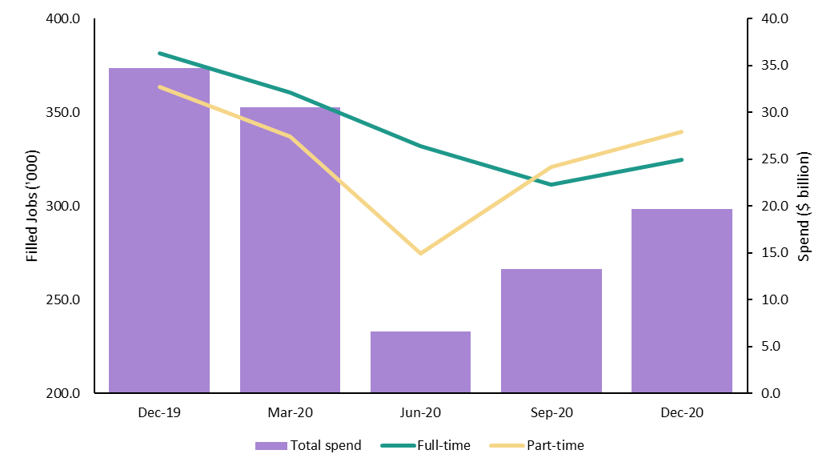

(Source: Australian Bureau of Statistics, Tourism Satellite Accounts: quarterly tourism labour statistics, Australia, experimental estimates, December 2020 release)

Aviation
Border closures and lock downs had a severe effect on demand for domestic flights. In April 2020 there were just 145,000 passengers on Australian flights – less than one-twentieth of the 3.1 million carried in March 2020. The recovery in domestic aviation since then has been slow. The 2.2 million passengers on domestic flights in December 2020 was only 42 per cent of December 2019 levels. For the Sydney to Melbourne corridor – Australia’s most popular route – the recovery was even slower, with demand down 76 per cent.
(Source: Department of Infrastructure, Transport, Regional Development and Communications, Domestic aviation activity, accessed June 2021)
Figure 13 – Demand for domestic flights, January 2020 to March 2021
(Source: Department of Infrastructure, Transport, Regional Development and Communications, Domestic aviation activity, accessed June 2021)
To remain viable over this period, operators increasingly turned to smaller planes as a way of achieving better seat utilisation. In January 2020, the average passenger plane had 126 seats, by May 2020 the average passenger plane had just 55 seats. Even with smaller planes, just 41 per cent of seats were occupied during May 2020, compared with 80 per cent in January 2020.
The recovery of domestic aviation was closely related to how safe people felt on flights. In August 2020, when the Victoria Covid-19 outbreak was in its worst stages, only 44 per cent of people surveyed said: “I would feel safe flying in Australia.” This steadily improved over the coming months and by December 2020, 72 per cent said they felt safe. The number of passengers on domestic flights almost quadrupled over this same period. This is due to a combination of:
- people feeling safer on flights
- relaxation of most state borders
- high demand over Christmas.
Figure 14 – Perceptions of flight safety and passenger demand, August to December 2020
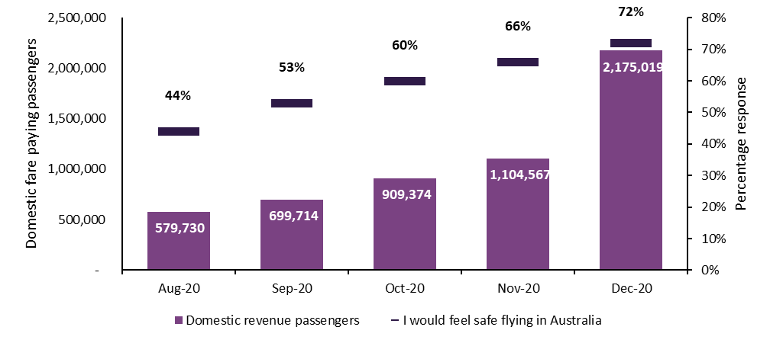
(Source: Tourism Australia, Domestic Travel Sentiment Tracker, accessed March 2021)

Accommodation
With high operating overheads, Australia’s hotels, motels and serviced apartments were particularly vulnerable to the downturn in demand. Many went into hibernation for prolonged periods, employing just enough staff to keep the premises secure and well maintained, but not accepting paying customers.
Hotels in the cities faced additional challenges due to:
- Their service offering – City hotels generally offer facilities and services that are aligned towards higher yielding travellers. As a result they have greater fixed costs than regional establishments and need higher occupancy rates to remain viable.
- More reliance on domestic business travel – In 2019, 38 per cent of domestic overnight visitor spend in the capital cities came from business travel, compared with just 20 per cent for the regions.
- The cessation of international travel – International visitors made up 36 per cent of capital city visitor spend in 2019; for Sydney and Melbourne it was even higher at 45 per cent and 40 per cent respectively. Outside the capitals it was just 7 per cent on average. In addition, the cities missed out on a market that was:
- Higher yielding – the average international holidaymaker staying in commercial accommodation spent $2,800 in Australia. This was almost three times the $1,000 spent by domestic holidaymakers.
- Less seasonal – Because international visitation was more consistent throughout the year, it enabled overall demand to be sustained outside of peak periods for domestic tourism.

Government support
For many years, Australia’s visitor economy was on a strong growth trajectory. In this environment the role of government was to facilitate growth, for example through the provision of tourism infrastructure and more streamlined visa arrangements, rather than through direct support. The tourism industry responded to increasing demand by increasing the supply of:
- Accommodation – through hotel investment from both foreign and domestic investors
- International aviation – leveraging off aviation agreements that opened up more international flights
- Domestic aviation – introducing new domestic routes, including routes that improved access to remote regional locations
- Visitor experiences – through investment in the infrastructure that supports arts, recreation, and business events.
2020 was the first time the industry became heavily reliant on direct government support.
The introduction of JobKeeper at the end of March 2020 was critical to the industry’s survival. It allowed businesses to retain staff, regardless of whether they could trade. This proved especially important during the early stages of the pandemic when businesses had to rapidly shut down and scale back operations.
Through 2020 and 2021, the number of businesses that were supported by the JobKeeper Payment gradually reduced.
Table 3 – JobKeeper support, March 2020 to March 2021
Period | Total businesses supported (average per month) | Tourism businesses supported (average per month) | Tourism workers supported (average per month)
March to September 2020 | 924,000 | 92,000 | 470,000
October to December 2020 | 507,000 | 57,000 | 271,000
January to March 2021 | 367,000 | 43,000 | 193,000

Targeted Government measures were also introduced through 2020 (and into 2021) to respond to industry requirements. Government support measures included:
- Bushfire support
- Zoos and aquariums
- Business events
- Regional tourism grants
- Travel agents
- Tourism and aviation network support
State and territory governments sought to drive demand, using vouchers to encourage people to spend more as travel restrictions eased. These vouchers were very popular and experienced large uptake. Examples include the Tasmanian’s Government’s travel voucher scheme which was fully subscribed within an hour of opening. Western Australia’s Wander out Yonder travel vouchers were snapped up in less than 4 minutes. Some of these voucher schemes were repeated due to overwhelming demand.

Marketing was also used to drive demand. With the suspension of international travel, Tourism Australia released the Holiday Here This Year campaign to encourage Australians to support domestic tourism operators and communities. Originally developed in January 2020 to support industry recovery from the bushfires, this campaign is still continuing.

What has happened since 2020?
The outlook for Australia’s Visitor Economy has improved significantly throughout 2021, along with a stronger than expected recovery for the national economy.
Domestic demand is on the rise. For the March quarter 2021 total domestic overnight and daytrip spend was $22.9 billion. While this was down 29 per cent on March quarter 2019 levels, it was 19 per cent higher than the $19.6 billion spend in the December quarter 2020.
Regional Australia destinations continue to recover faster than capital cities. With international borders closed, high savings and pent up demand, destinations in regional Australia continue to recover faster than capital cities. In the months of January to March 2021, domestic overnight spend in regional Australia has exceeded pre-pandemic levels (comparative months in 2019). However, with international borders closed and reduced business travel, domestic overnight spend in capital cities continues to suffer and cumulative losses continue to increase.
Figure 15 – Changes in domestic overnight spend in 2020 and 2021, compared to corresponding period in previous year
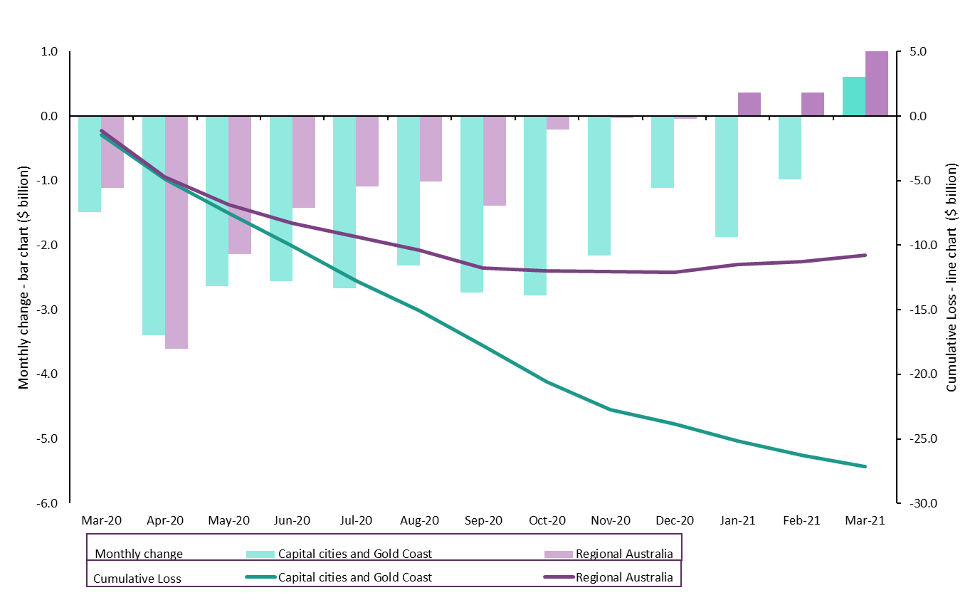
Investment has been maintained. In 2019–20 the value of Australia’s tourism investment pipeline was $43.6 billion across over 255 projects. This was only slightly down on the 2018–19 figure of $45.3 billion and reflects the longer-term view of investors, and the flexibility to delay large projects rather than abandon them altogether.
Employment continues to improve. In the December quarter 2020, tourism jobs fell by 10.8 per cent compared to December 2019. Although this is a significant overall decrease to the workforce, it is an improvement of 5.1 per cent compared to the September quarter 2020. It is also well above the seasonal increase that typically occurs between the quarters.
Airline performance is up. There were 2.8 million domestic passengers carried on domestic flights in March 2021, just short of the 3.1 million for March 2020, and almost twenty times as many as in April 2020. Planes are also being better utilised. The 67 per cent load factor for March 2021 was four percentage points up on a year earlier.

Table 4 – Changes in job numbers for Australia’s visitor economy, 2019 and 2020
Sector | December quarter 2020 compared to December quarter 2019 | December quarter 2020 compared to September quarter 2020
Sports and recreation services | -12% | 19%
Accommodation | -23% | 8%
Road transport and transport equipment rental | 5% | 6%
Travel agency and information centre services | -3% | 6%
Clubs, pubs, taverns and bars | -10% | 6%
Retail trade | 3% | 6%
Cafes, restaurants and takeaway food services | -10% | 4%
Education and training | -14% | 4%
Casinos and other gambling services | -13% | 3%
All other industries | -1% | 3%
Rail transport | -5% | 0%
Cultural services | -25% | -1%
Air, water and other transport | -41% | -2%

Looking forward
The Australia’s Visitor Economy is still facing significant challenges.
The reopening of Australia’s border is still a long way off. Australia has done a good job in keeping the spread of the virus under control. However, while other countries are looking to reopen borders, Australia is taking a more cautious approach. There are still many questions being asked globally that will influence quarantine-free international travel, including:
- vaccination rates and herd immunity
- the emergence of new, highly infectious Covid-19 variants and vaccine effectiveness against these new variants
- challenges associated with the resumption of international aviation, including the logistics of vaccine passports.
Aside from travel bubbles and small pilot programs, Treasury assumes that Australia’s borders will likely remain closed until mid-2022. The International Air Transport Association expects air travel to resume to pre-pandemic levels by 2024.
In the interim, the trans-Tasman travel bubble has proven to be popular. This allows quarantine-free travel between Australia and New Zealand. In April 2021, the month the travel bubble commenced, there were 16,320 short term visitor arrivals from New Zealand. While this is still 86 per cent lower than pre-pandemic levels (April 2019), it is almost a 700 per cent improvement on March 2021, which saw only 2,060 arrivals.
Travel bubbles are especially beneficial for the aviation industry. Increased air traffic allows operations to slowly resume, and increases employment across airlines and airports (including subsidiary businesses such as cafes and retail stores).
Travel bubbles have the added benefit of acting as valuable case studies in establishing protocols for safe flying. Issues such as social distancing, hygiene and limiting person-to-person interactions are able to be resolved through travel bubbles in anticipation of the future reopening of international borders.
Some businesses remain vulnerable. With borders closed for the foreseeable future, operators that have struggled to adapt their offerings to a domestic market – or in a region with a greater reliance on international tourism – remain at risk. Some sectors that fall into this category include:
- international education providers
- tour operators
- travel agents.
Education providers are of particular concern. The global market for international students is highly competitive and countries such as Canada, UK and USA remain open to students. Reports suggest that international students who may have studied in Australia are now turning to other countries that are allowing entry for students, regardless of high Covid-19 case numbers.
Australia’s skilled migration and post study-work rights policy settings are also less competitive, compared to Canada, UK and US. This could lead to difficulties in attracting international talent and skilled labour in the future. International students are a good source of labour for critical and seasonal industries such as agriculture, aged care and hospitality.
The international education sector has been one of Australia’s largest export industries, generating $40.3 billion in export revenue in 2019 (8.2% of total export revenue). It has traditionally also been a significant creator of jobs in Australia, supporting around 250,000 full time equivalent jobs in 2018. Covid-19 disruptions however resulted in job losses and a 21% drop in export revenue in 2020. Due to international students extended stay in Australia, and their significant social and economic contribution, the loss of these students will resonate for several years, even beyond the reopening of international borders. Strong and rapid recovery is therefore essential.
Lockdowns are continuing. The Delta variant has seen Covid-19 caseloads increase sharply since June 2021 and has led to the suspension of the Trans-Tasman travel bubble. State and territory governments are continuing to implement targeted lockdowns to control the spread of the virus. Unfortunately, this also results in travel cancellations and business closures, setting back the recovery of domestic tourism.
Labour shortages are emerging. Information from industry suggests that some operators are struggling to find suitable workers. In December 2020, 33 per cent of accommodation and food service operators indicated they were having difficulty finding staff. By June 2021, this increased to 38 per cent.
This is both a supply and demand challenge. For example, with less business travel, hotel demand is concentrated on weekends. This makes recruitment more difficult. Some businesses have had to scale back operations due to insufficient staff.
Compounding the issue is a lack of temporary migrants who used to fill some of these roles. These include people on the Working Holiday Maker program, and international students who often seek employment while studying.
To evaluate the long term outlook for Australian tourism, Austrade has established a panel of industry experts to advise industry and governments on the future of Australia’s visitor economy over the next ten years. Led by former federal Tourism Minister, the Hon Martin Ferguson AM, the panel is consulting extensively to identify what will be needed to secure a sustainable, profitable and resilient visitor economy in a challenging future environment.
<<START BOX>>
Even if Scott Brandon could find enough casual workers to fill all the vacant shifts at his Bright Brewery restaurant business, he expects they would struggle to secure affordable housing locally anyway. He is just now beginning to recoup the losses from the Black Summer bushfires and last year’s coronavirus lockdown, but the recovery is being hampered by the difficulty in finding staff. “There are some places in town that are closed a couple of nights a week because they can’t get enough staff,” Mr Brandon said. “It’s definitely having a massive economic impact on the town.” Victoria’s tourism sector has suffered a collapse of casual workers with new research showing almost half of them left the industry during the pandemic. The study by Victoria University found a lack of affordable housing was among the problems preventing workers from taking up jobs in the accommodation and hospitality industries. The research, in collaboration with the Victorian Tourism Industry Council, was based on a survey of 323 tourism businesses and interviews with some operators. It found that on average 46 per cent of casual employees were laid off permanently during the pandemic. While 91 per cent of businesses surveyed accessed JobKeeper, only 30 per cent of casual staff received these payments. Insurance costs are also mounting, with the research finding some operators faced major increases, particularly those in fire-affected areas.
(Source: The Age, Tourism sector suffers collapse of casual employee workforce, accessed July 2021)
<<END BOX>>

