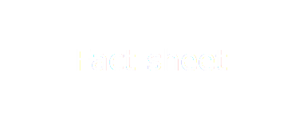

# First Nations tourism

**October 2024**

Insights on international and domestic tourism in Australia involving First Nations activities in the years from 2013–14 to 2023–24.

## Key insights

### A record year in First Nations tourism

There were a total 3.0 million trips that incorporated First Nations activities in 2023–24, the highest annual number of trips on record incorporating First Nations activities.

### Domestic and international participation

Of the 3.0 million trips incorporating a First Nations activity in 2023–24:

* 63% (around 1.9 million) were by domestic travellers, comprising:
  + - 1,223,000 domestic overnight trips
    - 664,000 domestic day trips
* 37% (around 1.1 million) were by international visitors.

International visitors from Europe (25%), and the USA and Canada (22%) were the most likely to incorporate a First Nations activity in their trip in 2023–24.

### Most popular First Nations activities

Experiencing an Aboriginal art/craft or cultural display was the most popular First Nations activity for international travellers in 2023–24. International visitors incorporated this activity into 813,000 trips.

Visiting an Aboriginal site or community was the most popular First Nations activity for domestic travellers in 2023–24. Domestic visitors incorporated this activity into 881,000 trips.

### States and territories

* New South Wales was the state with the highest number of domestic overnight trips that incorporated a First Nations activity. From 2021–22 to 2023–24, it had an average of 242,000 such trips per year (22% of the Australian total).
* The NT was the jurisdiction with the highest proportion of domestic overnight trips incorporating a First Nations experience. Such trips accounted for 15% of total trips in the territory per year between 2021–22 and 2023–24.

Note: analysis at a state and territory level combines the 2021–22 to 2023–24 financial years to ensure a robust sample size per state and territory.

All data is drawn from Tourism Research Australia’s (TRA) International Visitor Survey (IVS) and National Visitor Survey (NVS), except for International Demand for First Nations Experiences, which is provided by Tourism Australia.

## Background

In this summary, First Nations tourism is defined as a domestic day trip, a domestic overnight trip or an international trip involving one or more First Nations activities. Data on these activities is collected through the International Visitor Survey (IVS) and National Visitor Survey (NVS). Wording of activities in the questionnaires that capture First Nations tourism activities is below:

* Experiencing Aboriginal art/craft and cultural displays
* Visiting an Aboriginal site/community
* Attending an Aboriginal performance
* Going on a tour with an Aboriginal guide (2022 onwards)
* Participating in traditional activities (2022 onwards)
* Having an Aboriginal food experience (2022 onwards)
* Having a camping experience on Aboriginal land (2022 onwards).

The expanded list of questions from 2022 onwards (see above) has likely partly contributed to the increase in First Nations activities being selected. Data has been reported on a financial yearly basis. ‘Domestic overnight trip’ is a visit that involves at least one night more than 40 kilometres away from the visitor’s usual place of residence. Results have been rounded to the nearest 1,000.

No data is available for international travellers between 2019–20 and 2022–23 due to the suspension of the IVS during the COVID pandemic.

## Trips incorporating First Nations activities

Figure 1 and Table 1, below, show the growing number of trips incorporating First Nations activities between 2014 and 2024.

* In 2013–14, there were 1.5 million trips, made up of 0.8 million domestic day and overnight trips and 0.7 international trips.
* In 2023–24, there were 3.0 million trips incorporating a First Nations activity, consisting of
  + - 663,600 domestic day trips
    - 1,223,300 domestic overnight trips
    - 1,099,500 international trips.

Comparing trips between the pre-pandemic peak of the year ending December 2019 and   
2023–24:

* domestic day trips are up 17% or 96,700
* domestic overnight trips are up 25% or 248,400
* international trips are up 14% or 138,100.

***This bar graph shows total number of trips incorporating First Nations activities (domestic and international travellers). The chart covers 2013–14 to 2023–24. Across the period, the number of trips rises from 1.5 million trips divided into 800,000 total domestic trips and 700,000 international trips to 3 million trips divided into 1.9 million total domestic and 1.1 million international.  
In the year ending June 2024, the number of total number of trips incorporating First Nations activities surpassed the pre-pandemic level (year ending June 2019), and had 66 % (or 437,700) more total trips when compared to the year ending 2014.*Figure 1:** Total number of trips incorporating First Nations activities (domestic and international)

*Note: Labels show total trips for 12 months to June in each year on the horizontal axis.*

**Table 1:** Total number of trips incorporating First Nations activities

| **Financial Year** | **Domestic travellers** | **Domestic as % of total** | **International travellers** | **International as % of total** | **Total trips** |
| --- | --- | --- | --- | --- | --- |
| 2013–14 | 796,000 | 55% | 662,000 | 45% | 1,458,000 |
| 2014–15 | 670,000 | 49% | 685,000 | 51% | 1,355,000 |
| 2015–16 | 1,261,000 | 62% | 780,000 | 38% | 2,041,000 |
| 2016–17 | 1,123,000 | 55% | 920,000 | 45% | 2,044,000 |
| 2017–18 | 1,186,000 | 55% | 978,000 | 45% | 2,164,000 |
| 2018–19 | 1,395,000 | 59% | 965,000 | 41% | 2,361,000 |
| *2019*–*20* | 1,134,000 | *N/A* | *N/A* | *N/A* | *N/A* |
| *2020*–*21* | 1,167,000 | *N/A* | *N/A* | *N/A* | *N/A* |
| *2021*–*22* | 1,275,000 | *N/A* | *N/A* | *N/A* | *N/A* |
| *2022*–*23* | 1,668,000 | *N/A* | *N/A* | *N/A* | *N/A* |
| 2023–24 | 1,887,000 | 63% | 1,099,000 | 37% | 2,986,000 |

*There is no data for international travellers between 2019–20 and 2022–23 due to the suspension of the IVS during the COVID pandemic.*

## Domestic trips incorporating First Nations activities

In 2023–24, a total 1.9 million domestic trips incorporated First Nations activities, comprising:

* 664,000 day trips
* 1,223,000 overnight trips.

This total of 1.9 million trips was:

* 137% higher than the equivalent figure in 2013–14 (796,000 trips)
* 35% higher the pre-pandemic level in 2018–19 (1.4 million trips).

### Domestic demand for First Nations experiences

#### Domestic day trips

* Between 2013–14 and 2018–19, only 0.2% of domestic day trips incorporated First Nations activities.
* The proportion of domestic day trips that incorporated First Nations activities increased slightly since 2013–14, rising from 0.1% in 2013–14 to 0.3% in 2023–24.

#### Domestic overnight trips

* Between 2013–14 and 2018–19, 0.7% of domestic overnight trips incorporated First Nations activities.
* In 2023–24, the proportion of overnight trips including First Nations activities has seen a small increase to 1.1%.
* The higher share of domestic trips for purposes other than holiday – business or visiting friends and relatives – may contribute to the lower proportion of domestic trips that incorporate First Nations activities compared to international trips. International visitors typically have longer trips. They tend to have more stopovers and engage in more activities than domestic travellers. However, domestic travellers may take multiple trips each year with trips sometimes having a different purpose.

## International trips incorporating First Nations activities

The 1,099,500 international trips incorporating First Nations activities in 2023–24 is the highest number recorded. It is a:

* 12% increase on the previous high in 2017–18 (978,000 trips)
* 66% increase on the figure in 2013–14 (662,000 trips)
* 14% increase on the pre-pandemic level in 2018–19.

Table 2, below, shows the number of international visitors reported as taking part in a First Nations activity in 2017–18, 2018–19 and 2023–24. The proportion of total international visitors taking part in a First Nations activity was 15% in 2023–24, compared with 11% in 2018–19.

**Table 2:** International visitors incorporating First Nations activities in their trips in 2017–18, 2018–19 and 2023–24

| **International visitors** | **2017–18** | **2018–19** | **2023–24** |
| --- | --- | --- | --- |
| International trips incorporating a First Nations experience | 978,000 | 965,000 | 1,099,000 |
| Total international trips (IVS) | 8,367,000 | 8,601,000 | 7,353,000 |
| % of international trips incorporating a First Nations experience | 12% | 11% | 15% |

### International demand for First Nations experiences

Research conducted in May 2024 by Tourism Australia among out-of-region travellers (international travellers who have/are planning to travel outside of their region for a holiday) showed that just over 4 in 5 (82%) out-of-region travellers are interested in Indigenous experiences when travelling internationally.

The research found that:

* 34% of out-of-region travellers look for or consider tours/activities that respect and preserve local cultures and traditions
* awareness of Indigenous experiences in Australia was low
* only 12% of out-of-region travellers have a high or very high awareness of Indigenous experiences offered in Australia.

### First Nations experience engagement by country of origin

The share of trips including First Nations activities was higher across all countries of origin in 2023–24 than the average for the 2013–14 to 2018–19 period (Figure 2).

* International travellers from Europe, the USA and Canada were the most likely (25%) to include First Nations activities in their trip in 2023–24
* They were followed by those from Asia (12%)**.**

*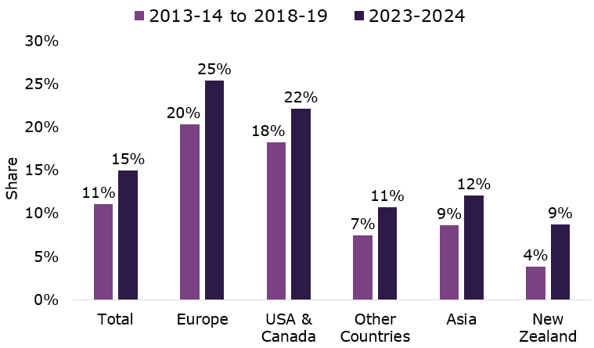***Figure 2:** Proportion of international trips that incorporated First Nations activities (by country of residence), 2013–14 to 2018–19, and 2023–24.

## Popular types of First Nations activities

The most popular First Nations activity in 2023–24 was:

* among domestic travellers, visiting an Aboriginal site or community
* among international travellers, experiencing an Aboriginal art/craft or cultural display.

### Participation of domestic visitors by specified activity

Table 3 shows the number of total domestic trips by specified activity and the share this represents of the total number of domestic trips incorporating a First Nations experience.

Data includes figures for 2017–18, 2018–19 and 2023–24.

Among domestic visitors, the top 3 activities were:

* Visiting Aboriginal sites/communities (882,000, or 47% of all domestic trips involving a First Nations experience)
* Experiencing Aboriginal art/craft and cultural displays (761,000 trips, or 40%)
* Participating in traditional activities such as Welcome to Country, storytelling, smoking ceremonies, and other cultural activities (455,000, or 24%)

**Table 3:** Domestic trips by specified activity

| **First Nations activity** | **2017–18** | **2018–19** | **2023–24** | **% of total (2023–24)** |
| --- | --- | --- | --- | --- |
| Visit an Aboriginal site/community | 620,000 | 723,000 | 882,000 | 47% |
| Experience Aboriginal art/craft and cultural displays | 755,000 | 901,000 | 761,000 | 40% |
| Participate in traditional activities (including Welcome to Country, storytelling, smoking ceremonies) | - | - | 455,000 | 24% |
| Go on a tour with an Aboriginal guide | - | - | 255,000 | 14% |
| Attend Aboriginal performance | - | - | 204,000 | 11% |
| Have an Aboriginal food experience | - | - | 145,000 | 8% |
| Have a camping experience on Aboriginal land | - | - | 72,000 | 4% |

### Participation of international visitors by specified activity

The most common First Nations activity undertaken by international visitors in 2023–24 was experiencing Aboriginal art/craft and cultural displays (Table 4). Three quarters (74% or 812,700) of international visitors undertaking First Nations activities in Australia in 2023–24 engaged in this activity. The next most popular activities were ‘Visiting an Aboriginal site/ community’ and ‘Attending an aboriginal performance’ undertaken by 18% and 15%, respectively.

**Table 4:** International trips by specified activity

| **First Nations activity** | **2017–18** | **2018–19** | **2023–24** | **% of total (2023–24)** |
| --- | --- | --- | --- | --- |
| Experience Aboriginal art/craft and cultural displays | 664,000 | 688,000 | 813,000 | 74% |
| Visit an Aboriginal site/community | 358,000 | 362,000 | 195,000 | 18% |
| Attend Aboriginal performance | 281,000 | 283,000 | 160,000 | 15% |
| Participate in traditional activities | - | - | 101,000 | 9% |
| Go on a tour with an Aboriginal guide | - | - | 83,000 | 8% |
| Have an Aboriginal food experience | - | - | 66,000 | 6% |
| Have a camping experience on Aboriginal land | - | - | 29,000 | 3% |

*Figures are for 12 months to June in each year (data on international travellers’ activities is unavailable for years between 2020 and 2022).*

## State and territory share of domestic overnight travel involving a First Nations activity

Table 5 and Figure 3, below, show the states and territories’ shares of domestic overnight trips that incorporated First Nations activities. Data in this section has been aggregated over the period from 2021–22 to 2023–24 to provide a more robust sample size, as sample sizes for a single year in individual states/territories are too small to produce reliable estimates.

During the period from 2021–22 to 2023–24:

* New South Wales (240,000 trips per year) had the largest share of domestic overnight visits with First Nations activities, with 22% of the national total
* Queensland (220,000 trips per year) had the second highest share of trips with First Nations activities with 20% of the total
* The ACT and Tasmania (30,000 trips per year) had the lowest share of trips with First Nations activities, with just 3% of total trips in 2023–24 including First Nations’ activities.

**Table 5:** State and territory share of domestic overnight trips that incorporated First Nations Activities (avg per year for the period from 2021–22 to 2023–24)

| **State/Territory** | **Avg domestic overnight trips per year with First Nations activity (2021–22 to 2023–24)** | **Change on avg per year for 2013–14 to 2018–19** | **Share of National trips with a First Nations activity (2021–22 to 2023–24)** |
| --- | --- | --- | --- |
| New South Wales | | 240,000 | 101% | 22% |
| Queensland | | 220,000 | 123% | 20% |
| Northern Territory | | 200,000 | -1% | 19% |
| Victoria | | 170,000 | 167% | 15% |
| Western Australia | | 150,000 | 76% | 14% |
| South Australia | | 60,000 | 40% | 5% |
| Tasmania | | 30,000 | 295% | 3% |
| ACT | | 30,000 | 86% | 3% |
| **Total** | | **1,100,000** | **73%** | **100%** |

**Figure 3:** State/territory share of domestic overnight trips incorporating First Nations activities in 2021–22 to 2023–24**.**

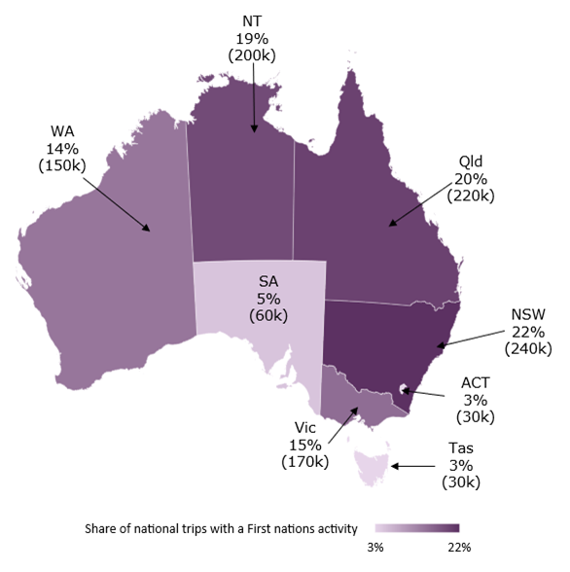

### Share of trips with a First Nations activity out of total trips to each state/territory

* The Northern Territory led with 15.0% of total domestic overnight trips to the NT incorporating a First Nations activity
* Trips with a First Nations activity accounted for under 1.5% of total domestic overnight trips in all other states and territories
* Only 0.7% of domestic overnight trips to New South Wales and Victoria incorporated First Nations activities (the lowest proportion of any states, see Table 6).

**Table 6:** Domestic overnight trips incorporating a First Nations activity as a share of total overnight trips per state/territory

| **State/Territory** | **Avg trips per year with a First Nations activity in 2021–22 to 2023–24** | **Total avg domestic overnight trips per year (2021–22 to 2023–24)** | **First Nations share of trips in 2021–22 to 2023–24** |
| --- | --- | --- | --- |
| Northern Territory | 200,000 | 1,385,000 | 15.0% |
| Western Australia | 150,000 | 10,664,000 | 1.4% |
| Tasmania | 30,000 | 2,952,000 | 1.2% |
| ACT | 30,000 | 2,702,000 | 1.2% |
| Queensland | 220,000 | 24,188,000 | 0.9% |
| South Australia | 60,000 | 7,003,000 | 0.8% |
| New South Wales | 240,000 | 32,736,000 | 0.7% |
| Victoria | 170,000 | 25,397,000 | 0.7% |
| **Total** | **1,100,000** | **103,648,000** | **1.1%** |

## References

* Tourism Research Australia (TRA) International Visitor Survey, to year ending June 2024
* Tourism Research Australia (TRA) National Visitor Survey, to year ending June 2024
* Tourism Australia Consumer Demand Project, June 2024

Data with respect to activities are based on how questions are currently phrased in the International Visitor Survey and the National Visitor Survey questionnaires.

*All data sources were rounded, accurate and up to date as of 28 October 2024.*

**Note:** Due to the COVID-19 pandemic and related border closures, which disrupted survey collection activities, data is not available for international visitors between 2020 and 2022. The IVS was therefore imputed from April 2020 to December 2022. During this period TRA used Overseas Arrivals and Departures data, along with similar interview records from past survey data, to estimate geographical visitation and expenditure.